
K&M Tire
Adjustments SOP Binder
4/18/2025

Table of Contents
1. K&M Tire 1
2. Tire Basics 3
2.1 Tire Construction 3
2.2 Tire Dimensions 5
2.3 Aspect Ratio 6
2.4 Speed Symbol 6
2.5 Load index (LI) 7
3. Intranet Portal 8
3.1 Search Claim 8
3.2 Submitting a claim 10
4. Madden-Co 14
4.1 Clearing out an estimate 14
4.2 How to search for a customer 16
4.3 Checking for the customer purchase history: 17
4.4 How to release a receiver 21
4.5 Over/Short Account (101092): 23
4.6 How to write a new return credit 26
4.7 How to look up invoices 30
4.8 How to look at inbound adjustments 31
4.9 How to find the current cost of a tire 33
5. Weblink 35
5.1 Weblink 35
5.2 Tire Warranty Information 37
5.3 SOP# 2 37
5.4 SOP #3 38
6. Inbound RAR 39
6.1 Inbound Adjustments 39
6.2 RAR Adjustments 39
6.3 SOP #3 44
6.4 Inbound Defects and Mis tags 44
6.5 Field Adjustment 44
7. K&M Road Hazards 47
7.1 Documentation 48
7.2 Processing the claim 48
7.3 SOP #3 51
8. Hankook PLT 52
8.1 Hankook PLT Warranty 52
8.2 The Warranty Guidelines 54
8.3 SOP# 2 56
8.4 SOP #3 56
9. Cooper/Mastercraft PLT 57
9.1 Filling out the spreadsheet 57
9.2 The Warranty Guidelines 60
9.3 SOP# 2 61
9.4 SOP #3 61
10. Falken PLT 62
10.1 SOP# 2 66
10.2 SOP #3 66
11. Goodyear & Kelly PLT 67
11.1 Goodyear/Kelly ADJ Procedures 67
11.2 The Warranty Guidelines 72
11.3 Immediate Rejections 74
12. Bridgestone/Firestone PLT Procedures 76
12.1 The warranty Guidelines 79
13. Carlisle/Carlstar AG Adjustment Procedures 82
13.1 The warranty Guidelines 83
14. BKT AG Tires 85
14.1 BKT AG Warranty 85
14.2 What is warrantable BKT Radial 87
14.3 What is warrantable BKT Bias 88
14.4 SOP# 2 89
14.5 SOP #3 89
15. Firestone AG Procedures 90
15.1 The warranty guidelines: 95
15.2 Radial Tires: 95
15.3 Performer Evo Radials 96
15.4 Bias Tires 96
15.5 Forestry Tires 97
15.6 Stubble Damage 97
15.7 Field Hazard 98
Appendix A: Supportive Documents 99
Appendix H: Revision History Tracking 100

K&M Tire


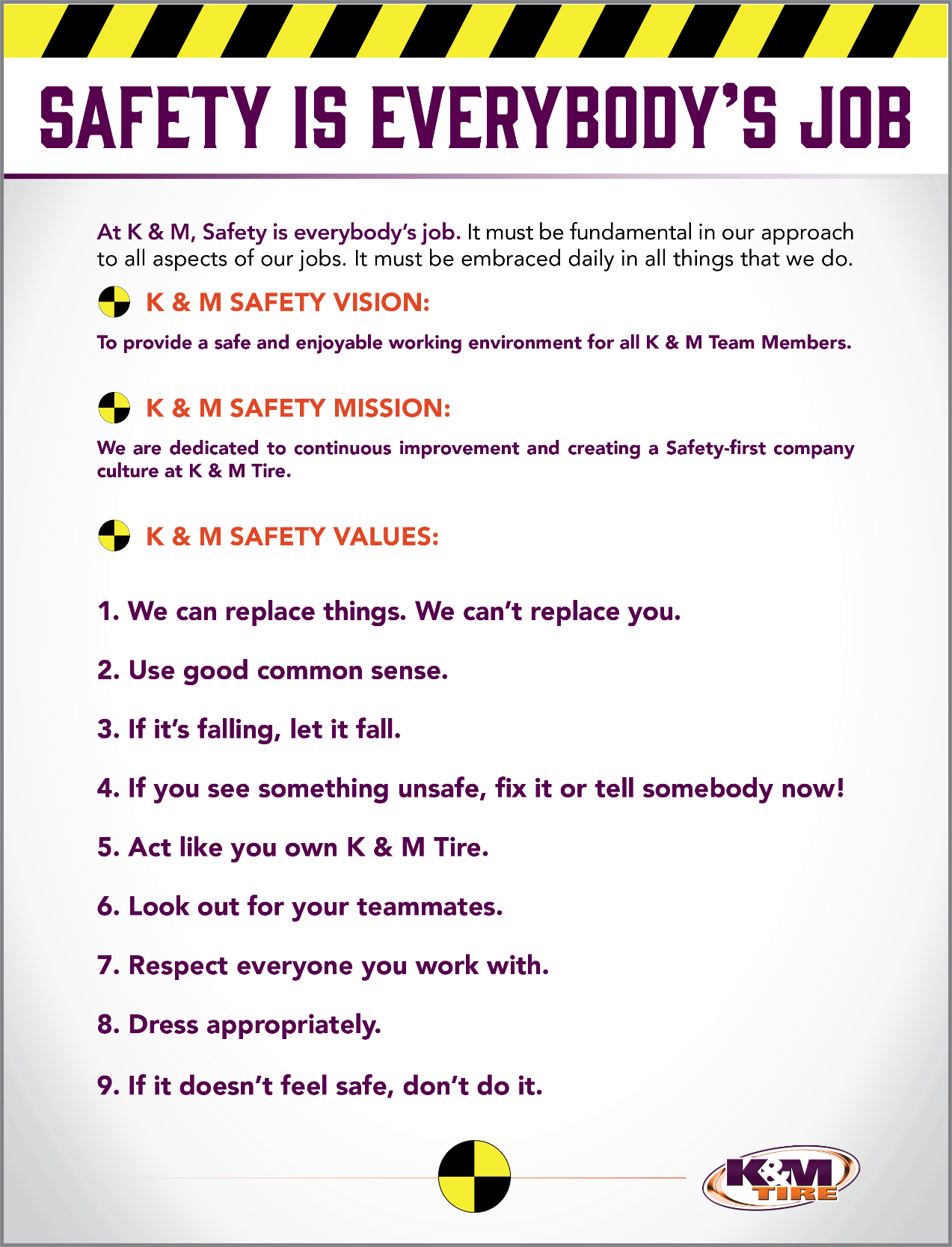

Tire Basics
In the adjustment department to make the best use of a tire it is essential to understand it’s basic features properly. A strong belief that a thorough awareness of the basic features of a tire will lay a firm foundation for its best use, such as in the fields of performance, proper usage, safety, and economy. Knowing basic tire information such as tire construction, tire dimension, aspect ratio, speed symbol, and load index will give you the tire terminology to help you better perform your job duties and knowledge of tires and what to be looking for in the adjustments.

Tire Construction
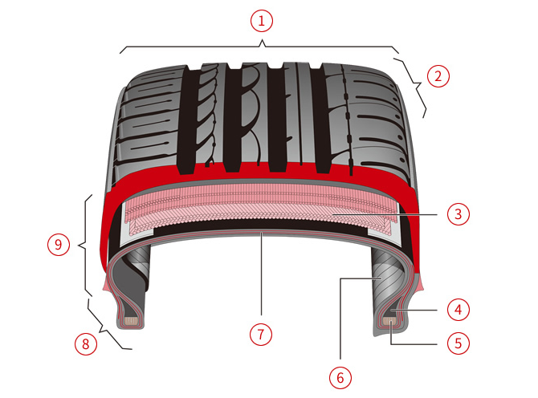
- Tread
The tread is the part of a tire that contacts the road surface.
the tread consists of a layer of rubber, compounded to suit the application purpose of the tire, and the thickness serves to protect the belt and carcass. Depending on application a suitable tread pattern is molded at the time of curing. The tread pattern serves the purpose of improving water drainage, providing traction, braking, and cornering characteristics and aiding in NVH performance.
- Shoulder
The shoulder on each side of the tread is designed to protect the belt and carcass of the tire and to dissipate heat generated during running to the atmosphere.
- Belt
The belt is a reinforcement layer extending around the outer circumference of the carcass under the tread. It acts like an iron hoop in improving the stiffness of the tread area.

- Bead filler
This is a reinforcement rubber that has a triangular cross-section, and which is used to increase the stiffness of the bead.
- Bead wire
A ring-shaped reinforcement material that is made by bundling together several steel wires.
- Inner liner
The inner liner is a layer of special rubber that has high resistance to air migration.
- Carcass
The carcass is the load-bearing framework that forms the body of the tire. It is composed of rubber coated fabric laid in a radial direction. The carcass contains the inflation pressure aiding in supporting the load and absorbing impact.
- Bead
The bead area supports the extremities of the carcass on each side of the tire. This is the part of the tire that anchors the tire to the wheel.
- Side wall
The sidewall on each side of the tire, between the shoulder and the bead is the section that deflects most during running. The rubber coating serves to protect the carcass.

Tire Dimensions
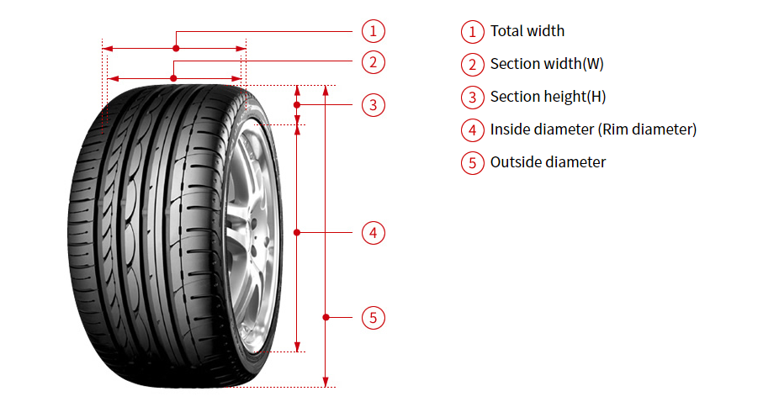
- Total width
The exterior measurement of a tire’s width from inner to outer sidewall (including protective ribs and decorations) when properly mounted and inflated.
- Section width(W)
The exterior measurement of a tire’s width from sidewall to sidewall (excluding protective ribs or decorations) when properly mounted and inflated, but with no load placed upon the tire.
- Section height(H)
The measurement of the vertical distance between the tire’s bead seat and outer tread surface when properly mounted and inflated, but with no load placed on the tire.
- Inside diameter (Rim diameter)
The linear distance between bead seats measured at the widest point. This measurement may be in inches or millimeters.
- Outside diameter
The linear distance between the tire’s tread surfaces measured at the widest point. This measurement is taken with the tire mounted on the measuring rim and no load applied. 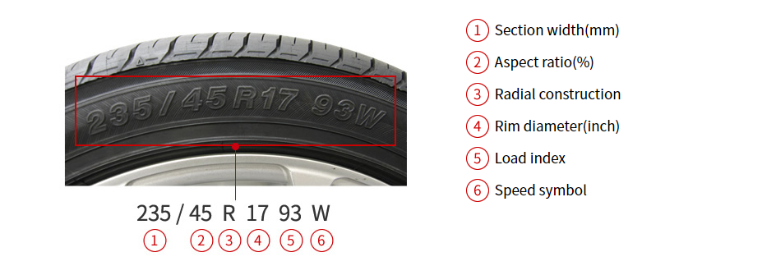

Aspect Ratio
Aspect Ratio is the section height expressed as a percentage of the section width (e.x. 70,65,60, etc.).

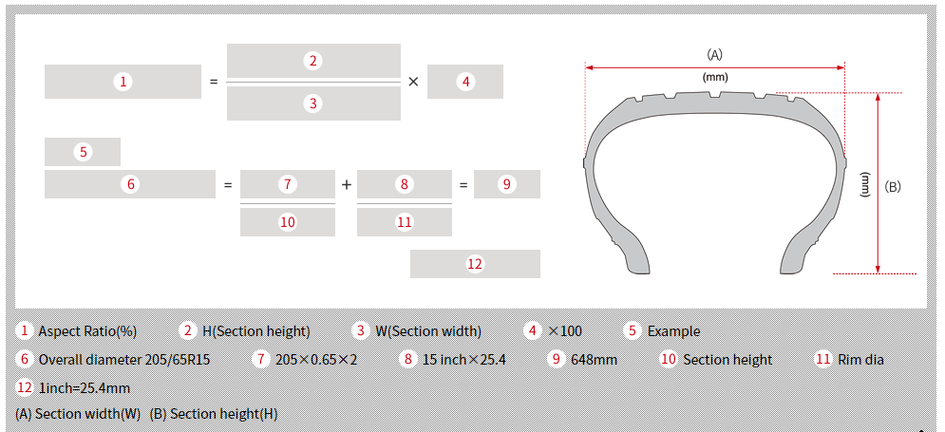

Speed Symbol
The SPEED SYMBOL indicates the maximum speed at which the tire can carry a load corresponding to its Load Index under service conditions specified by the tire manufacturer. (except for speeds above 210km/h, see the above section, “Load capacities and speed limits” respectively for Passenger Cars)
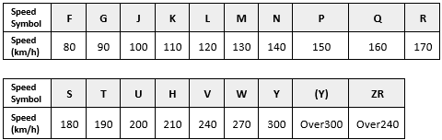

Load index (LI)
The capacity of each tire in withstanding the load is referred to as the load capacity. The load index is a numerical code associated with the maximum load a tire can support.
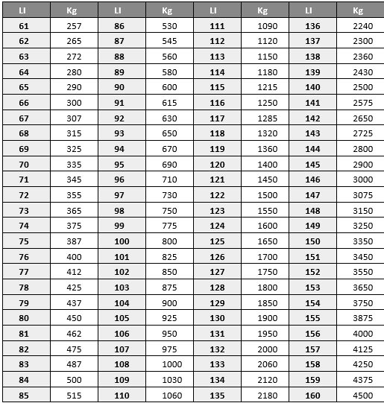

Intranet Portal
It is Adjustments’ responsibility to process every warranty claim here at K&M. So, this is critical to know and understand how we process every warranty claim through the intranet.

- Visit http://intranet.kmtire.local/index.php?area=adjportal
- Log in using your username and password that will be provided.
- Click on Adjustments- Adjustments Portal
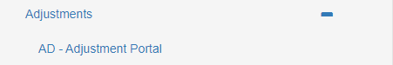

- This is the home page for Adjustment’s portal, here we can search and start for claims.
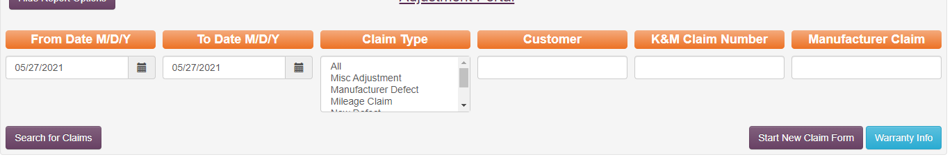

Search Claim
- Select a date range.
- Pick a claim type.
- Enter customer #, the claim #, or manufacturer claim #.
  - Example: K&M claim is 211776 the customer is 404287 if you click all for the claim type then selects the date range from the last this will show.
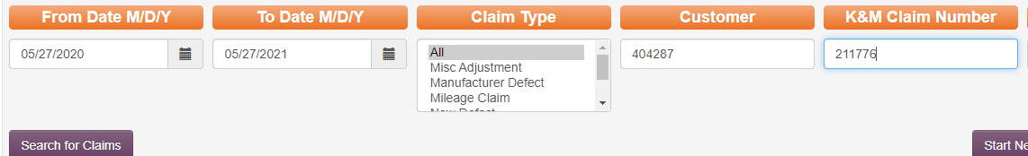

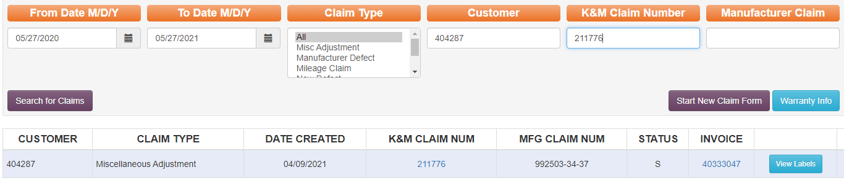

- If you click on the claim number, the below screen will populate, and this is where you see what information has been entered. Including the tread, we recorded the tire at, part number used, credit amount given, pictures of the tire, any documentation, and the reasoning.

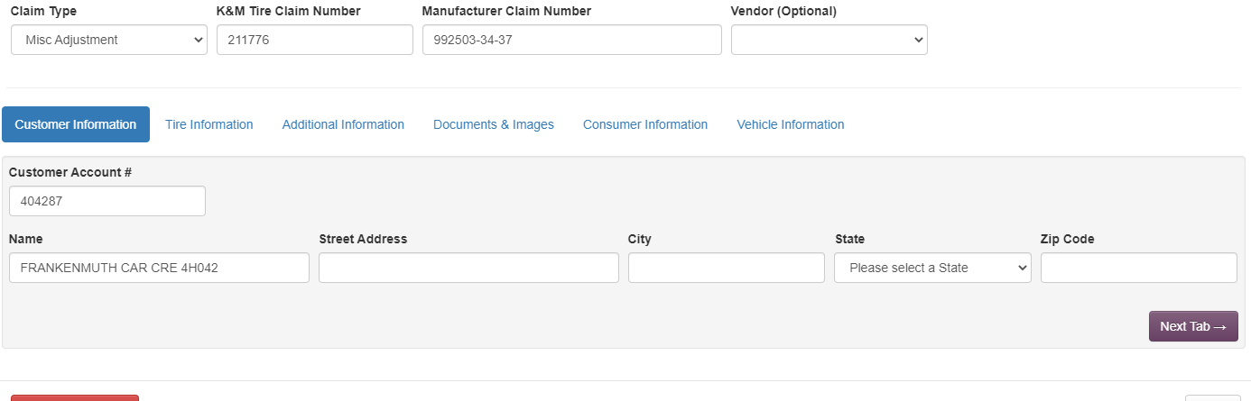

- If you were to click on the invoice number, this will open a new window up with the customer information and the invoice.
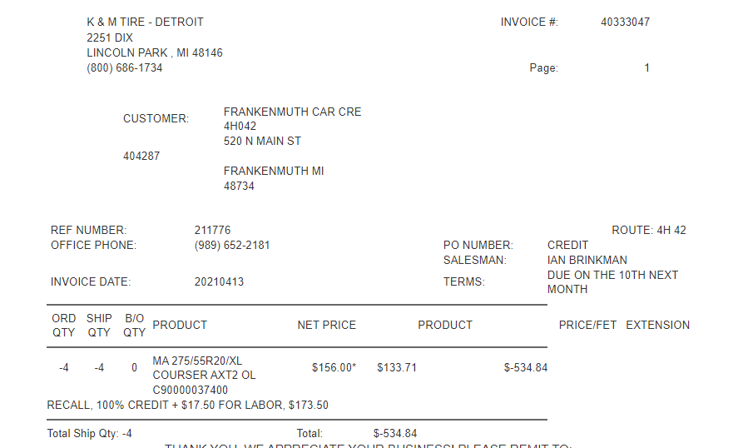

Submitting a claim
- Be on the home of Adjustments.
- Click on Start New Claim Form.

  - Now you will need to enter the customer account number and choose the claim type.
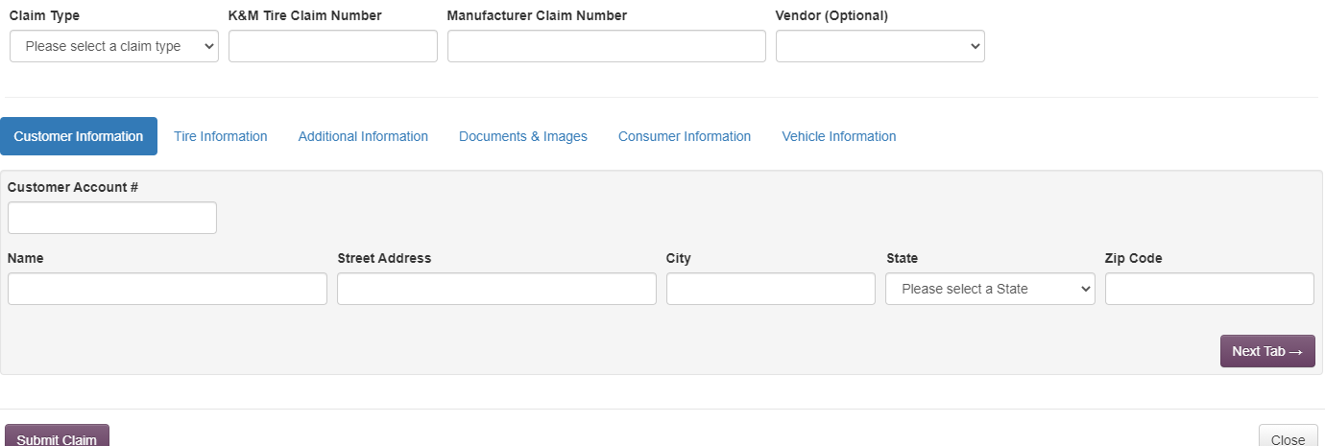

  - There will be 6 different claim types to choose from (Choosing the correct claim type is essential).
    - Misc ADJ- Is anything that you will have to edit the price on
    - Manufacture Defect- is anything that is 100% credit due to the tire failing from production.
    - New Defect- is anything that comes from our stock never sold to a customer.
    - Mileage Claim- Is anything that is going to be processed based on miles driven but not meeting the tire mileage life of the tire.
    - RAR- is anything we are rejecting due to the tire not meeting the warranty guidelines.
    - Road Hazard- is anything that is going under K&M’s RH program that will not hit adjustment tracking.
- From here you will need to enter in K&M’s claim number along with the manufacturer’s claim number.
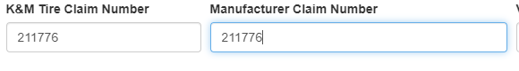

- Next you enter the tire information. If the purchase date is not available, then the current date can be used. Be sure to fill out all the information on this section.

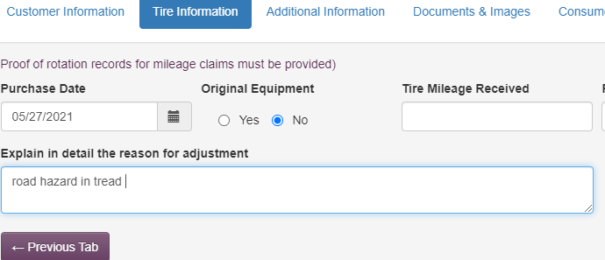

- Next tab which will be the additional information here you will need to enter the DOT of the tire which is found on one sidewall of the tire. Enter in the correct product number for the claim you will enter in the remaining tread depth (for misc. claims make sure if they are supposed to get 100% you change the price back otherwise it will pro-rata). The message line will need to include the reasoning for the adjustment along with the credit amount percentage.
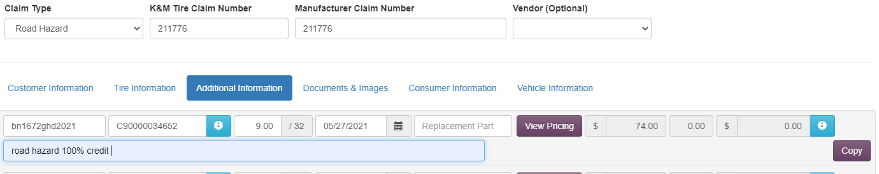

- To get the price of the tire click the view pricing button. This will pull up a menu of the purchase history with the associated part number. From here find the date from the end user to the dealer (our customer) if this is not provided you are able to use the DOT with most vendors.
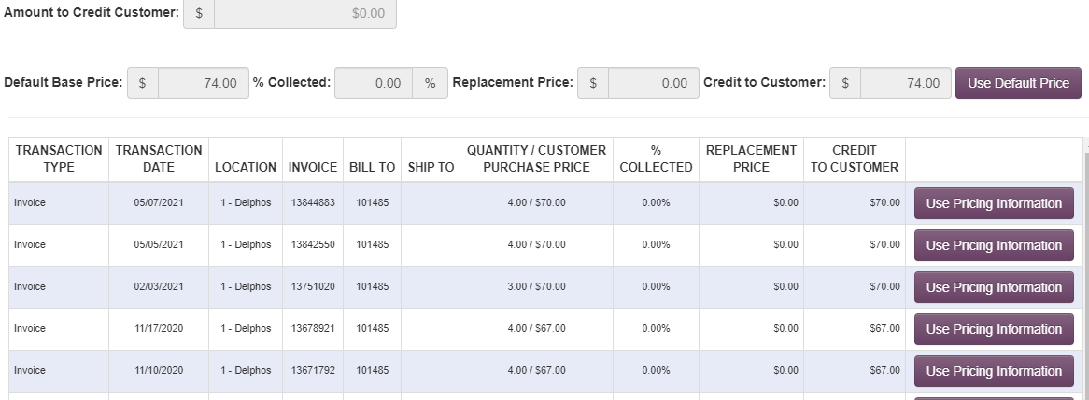
- Here you will see all the invoices along with the price they purchased the tire at so let’s say they bought this on 02/03/2021 We need to use the price from that date not the current price of the tire which is $74.00 compared to what they bought it at which is $70.00 just click the use pricing information button for that invoice.

- Now we can see the price has changed to $70.00, which is what we want. If we click on the blue information button, we can see the percentage of credit we are giving back.
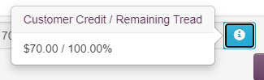

  - If you have two or more of the same tires there is a copy button it will auto-generate the same information onto the next line.
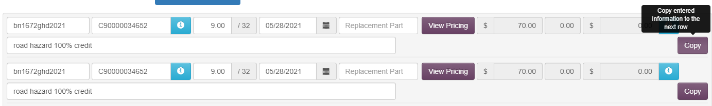

- Utilize this tool but if any information is going to be different for the other tire you will need to edit that information on the next line.
- Now you can move over to the next tab which is the document and images.
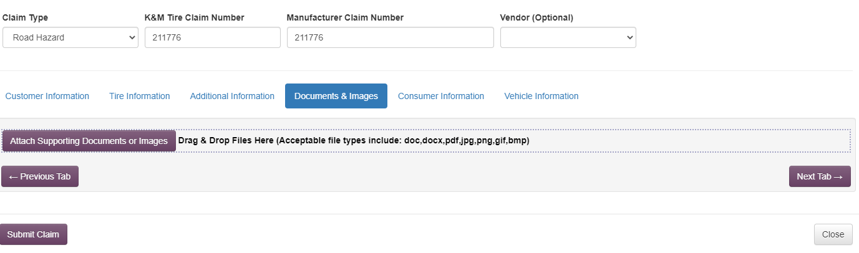

- Here you can click attach support documents this will allow you to pick whatever file you need to for the claim. Generally, it will always be K&M’s claim form, Manufacture claim form if required, purchase invoice, and replacement invoice. The portal will allow you to drag and drop images from your email these will be the tread depth gauge in the tread, whole sidewall, DOT, and the condition the tire is being sent in for the more pictures the better but then total storage amount for every claim should be 3MB.

- From here you are finished with the claim you can press submit claim.

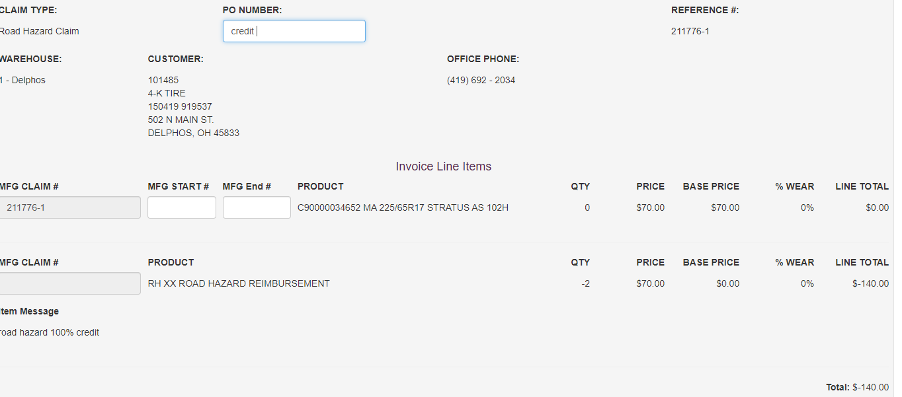

- This is the screen that will show up from here is it is a credit the PO needs to say Credit and if the claim is an RAR it will need to say RAR or NADJ.
- After every claim it will need to be added to a shipping spreadsheet every tire has one except for RAR and K&M road hazard claims.

Madden-Co

Clearing out an estimate
- From the main page press 1-1-7-1

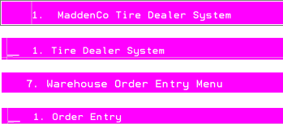

- Enter in the location number this is usually the first one or two digits of the customer number Example: Customer number 101485 is loc 1 customer and customer number 550155 is a loc 55 customer number. Look over the location list if unsure.



- Once a location is entered proceed to enter in the customer number
Example:

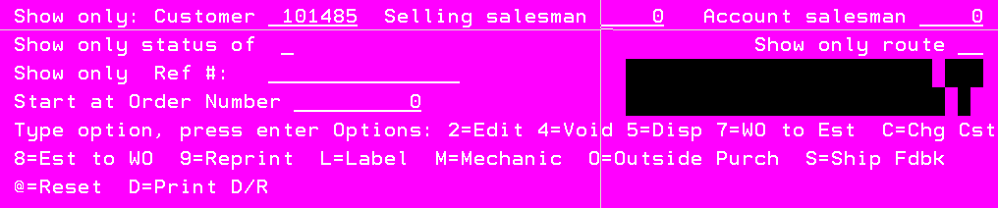

- Press enter and all of the customers’ current orders along with estimates will show up.

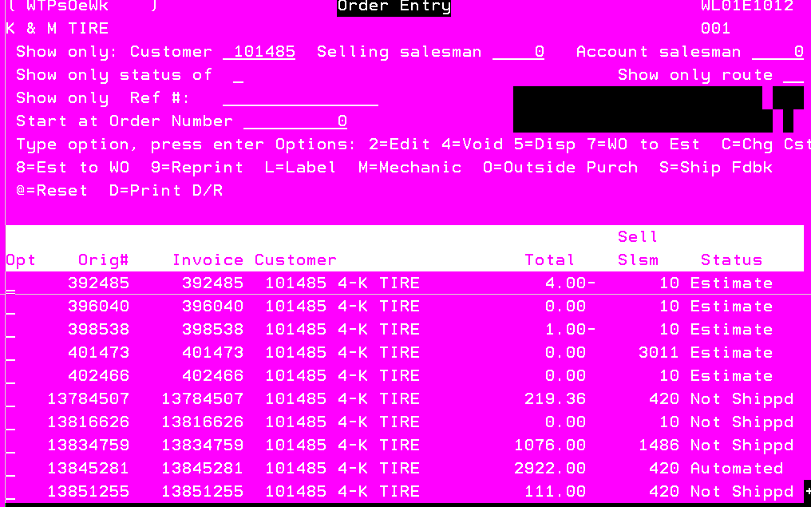

- From here find the estimate with the tire/claim either do this by looking for the exact estimate or viewing all estimates. To do so place a 5 on the line then enter.

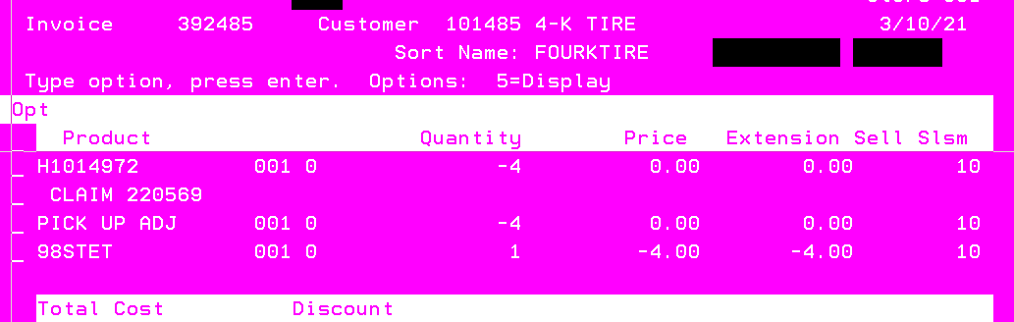

- Once confirmed those are the tires press F12 to exit. Find the estimate that needs deleted. Put a 4 on the line then enter.

- This screen will pop up asking for a salesmen number along for a password. Enter in current salesmen number and the password will be VOID
Example:

- Press enter and put a Y for yes you want to Void.

- It will ask for a reason why always put ADJ PORTAL

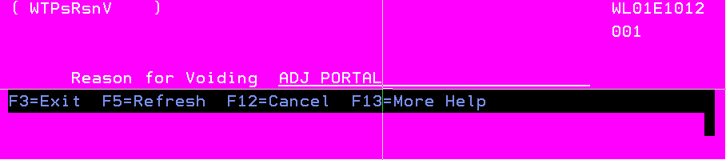

- Press enter and now the estimate has been cleared out of the system.

How to search for a customer
- From main page press 1-1-7-1

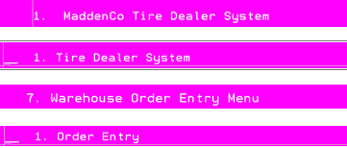

- Enter loc 1 from there, go to the customer line and put in a F4. The screen that will pop up is shown below entering in the customer’s name, city, or state will pull up anything related to the search.

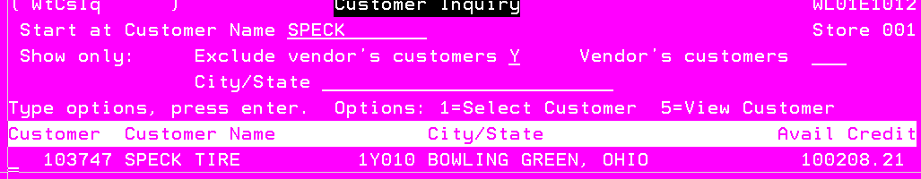

- From here putting a 5 on the line and pressing enter will give all the customer information needed to check to see if the store address is the same as the claim form information.
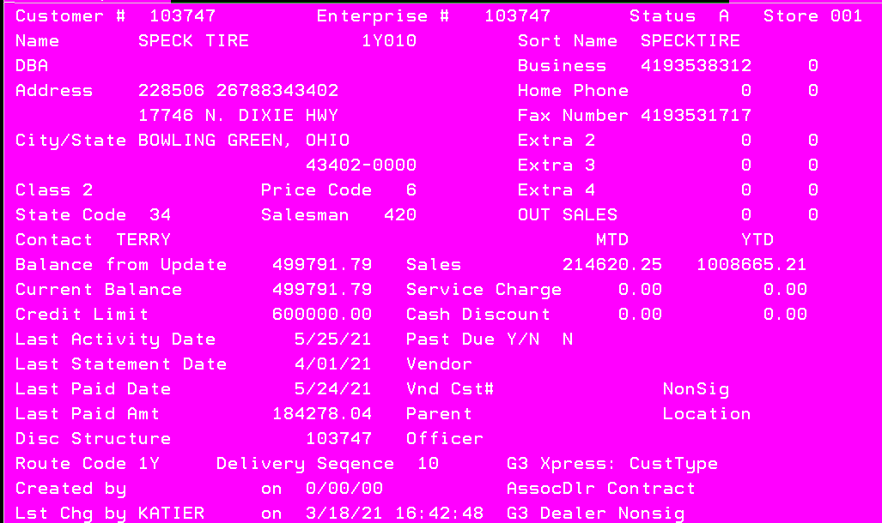

- From here provided is the customer number and any other information needed.

Checking for the customer purchase history:
When processing a claim check and make sure the dealer purchased or replaced the tires with K&M Tire if not either the tire becomes as RAR.

- Go to the main page press 1-1-7-1

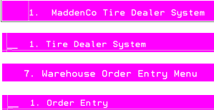

- Then go to the location the customer is based out of.

- Enter in the customer number.


- From here there are two ways to search, either press F2 or do a shift F2.
  - When you search with F2 this menu will pop up.
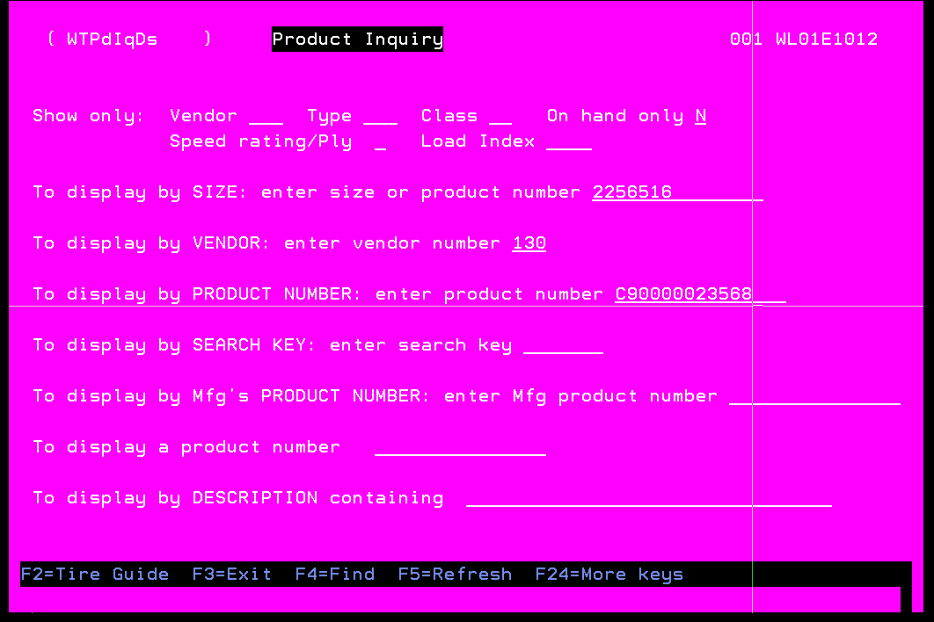

- From here input any of the required information once you press enter the tire should pop up on the following screen. To check the history, place a C on the line and any product history associated with that tire and customer will show.

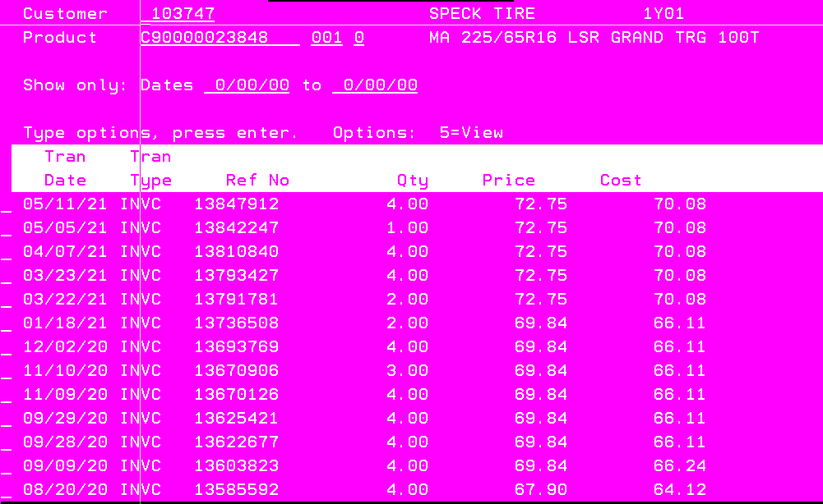

  - Now I know they have purchased this tire from us, and I can continue the claim.

- The second way to search is by using shift F2 this will pull up everything they have bought with us. Go back to the customer main page and do the following shift F2 this menu will pop up.

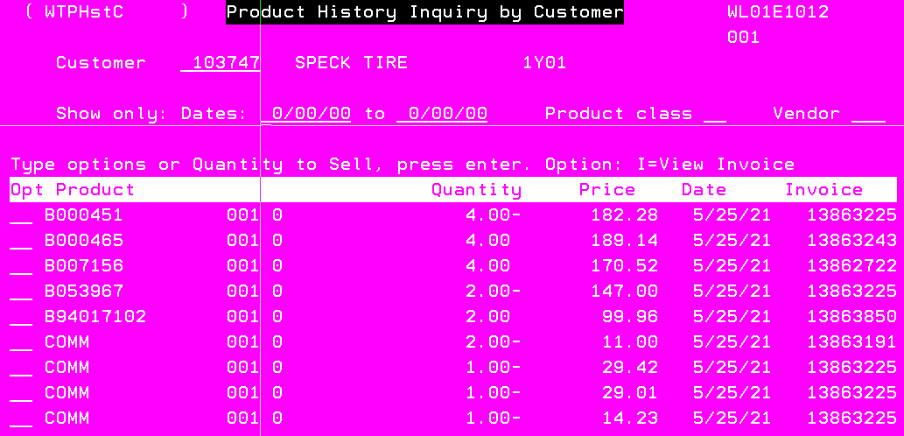

- You will have to page down based on the date and tire you are searching for here. You cannot put a 5 on the line, you must put an I to view.

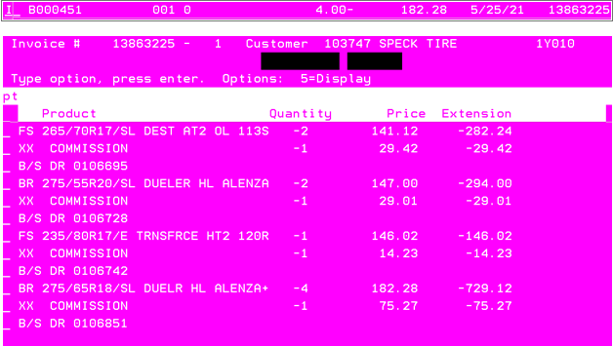

- This will show everything that was on that invoice and what they purchased. If you want to narrow the search you can go to the vendor line and place an F4, this will allow you to choose a vendor.



- From here all the vendors we carry will pop up. You will find the tire brand you are searching for then place a 1 on the line. It will then pull everything up for that vendor that the customer has purchased with K&M.

How to release a receiver
When tires come off transfer trucks or are billed from warehouse to warehouse the invoice must be released so it is received into that location’s inventory.
Adjustment sees this most commonly with defective tires that come from K&Ms stock. If the warehouse doesn’t get the adjustment paperwork to release the invoice it will sit there until released.

- Go to the main page 1-1-3-3

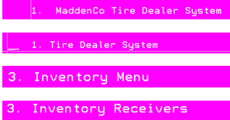

- Enter the location the tire is being received in.

- This will be the page that pulls up the report number is going to be the invoice that needs released. Anything that says on hold hasn’t been released yet anything with a ready next to it has been released. The beginning of the report number is the location the tire came from to see all the location invoices page down and up.

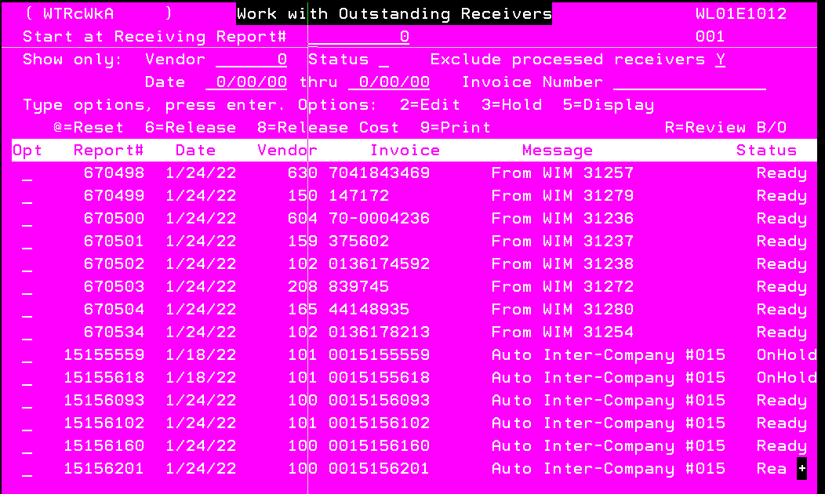
- Once the invoice number is found in order to release the invoice a 6 will need put on the line.

- Then press enter this will release the invoice putting the tire into the locations inventory.

- If the tire is a defective tire, it must be allocated to an over/short account otherwise this defective tire can be sold to a customer. Adjustments has an over/short strictly for defect this is called 101092.

Over/Short Account (101092):
101092 is the adjustment department over/short account anything that is a defective tire from K&Ms stock will be allocated to this account so the tire can’t be sold to a customer, and it can be taken out of inventory properly.
Once a defective tire is released from the receivers it must go onto this account.

- Go to the main page press 1-1-8-4

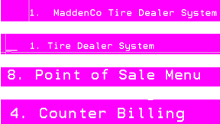

- Enter the location in this case it will always be loc 1.

- From here 101092 needs entered in the customer line.

- There will be a single work order this is holding all the defective tires from being sold.

- To add or take away a tire from this account a 2 will need placed on the line.

- The next page can be skipped by pressing enter.

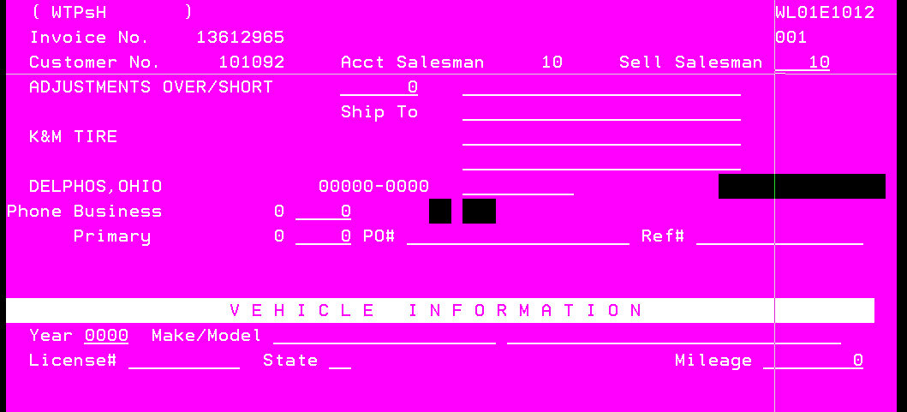

- To delete a tire off this account put a 4 on the line that needs taken off if that is the tire press enter (make sure it is the correct tire and the quantity is right)

- To add a tire to 101092 press F6 to create a line then enter the product number that needs to be added.
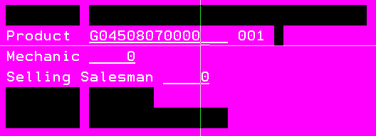

- Change the quantity to how many tires there is total and do not change the price.

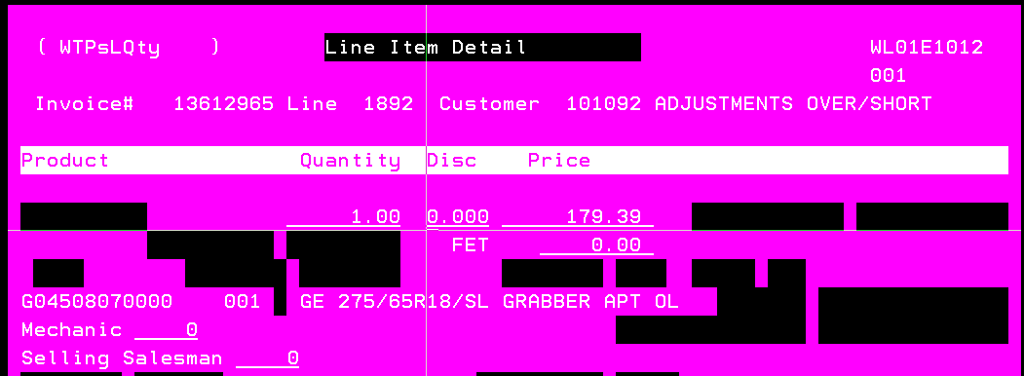

  - The most important part of 101092 is to make sure when exiting the work order it doesn’t get invoiced out if this happens all the tires on this account will be released into inventory allowing them to be sold.

- To close the work order press F3
- This menu will pop up ALL LINES NEED TO HAVE A N ON THEM this makes it, so it doesn’t invoice out.
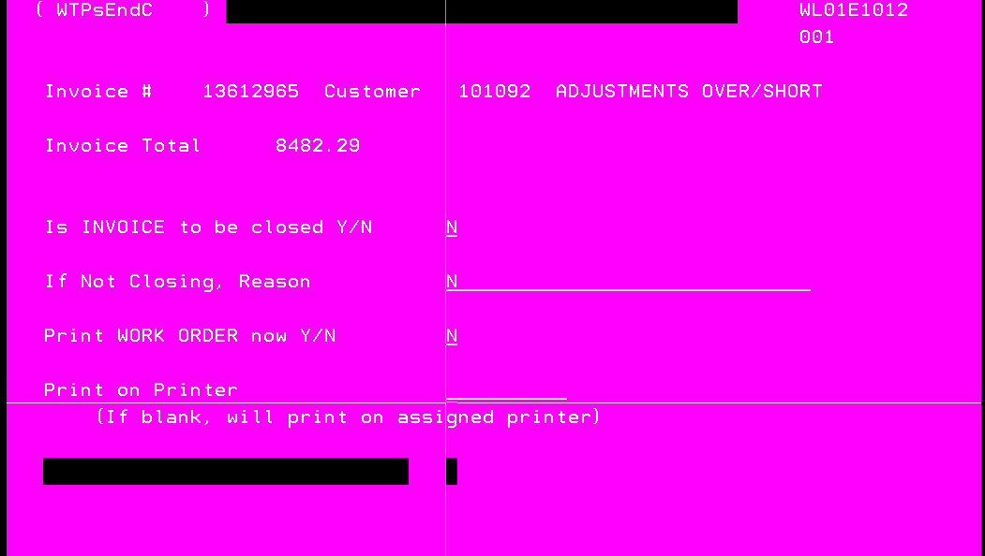

How to write a new return credit
Adjustments will typically write new return credits for customers that have purchased a tire and upon mounting discovered that it has shipping damage.
A new return credit will issue a credit to the customer based on their original purchase invoice in doing so this will add a tire back into the warehouses inventory depending on where the credit is being written out of.

- First go to the main page and press 1-1-7-1.
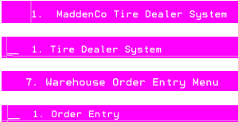

- Go to the location the customer is based out of.


- Enter the customer number.

- Then press F2 to search for a part number, go down to the third line and enter the part number of the tire.

- Place a C on the line this will show all the purchase history for that part number out of this location for this customer.

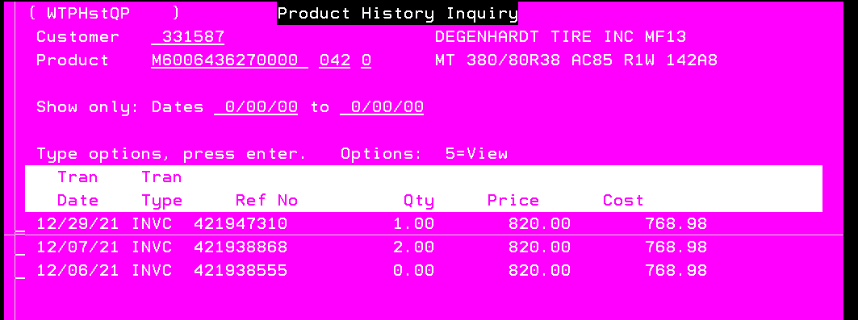

- When trying to find what the original purchase invoice does what makes sense so if they brought two originally on invoice 421938868 now, they are return one due to damage and they brought another one around the same time frame so the invoice for the two is the original invoice needs to be used. If they would’ve only had the invoice for the two and no replacement that same invoice would be used.
- Now that the original purchase invoice/price is known the credit can be written. Since the tire would be in location 1 (Delphos) the credit needs to be issued out of location 1 NOT the location the customer is out of. Back out to the main menu and 1-1-7-1.
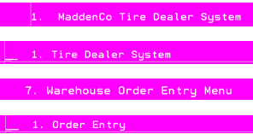

- From here enter location 1 to issue the credit out of the correct location.

  - Even though this is location 33 customers the credit is going to be written out of location 1 because that is where the tire is located currently and when the credit is issued it will then put that tire into location 1 inventory.
- Enter the same customer number in.

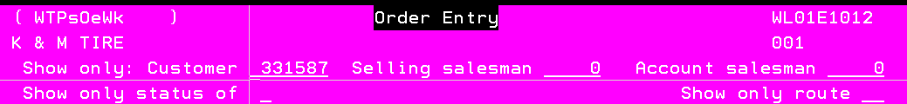

- Then press F6-F6 to create an invoice then enter in the salesmen number issuing the credit along with the PO this needs to be new return credit.

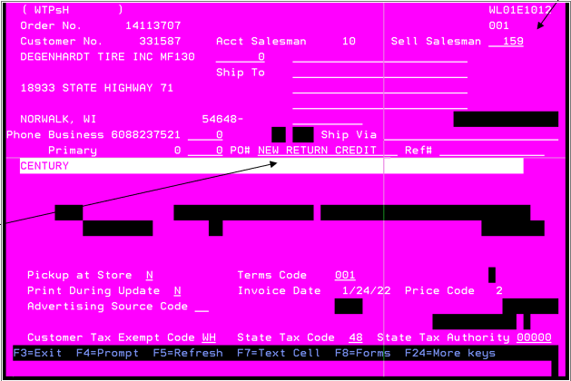

- Press enter then from here enter in the product number the credit is for.

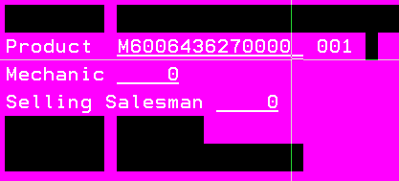

- Press enter then the quantity for the credit needs entered with a - sign after it so in this case 1.00- and the price needs to be what they bought the original tire at if they had FET they are allowed to collected that as well.

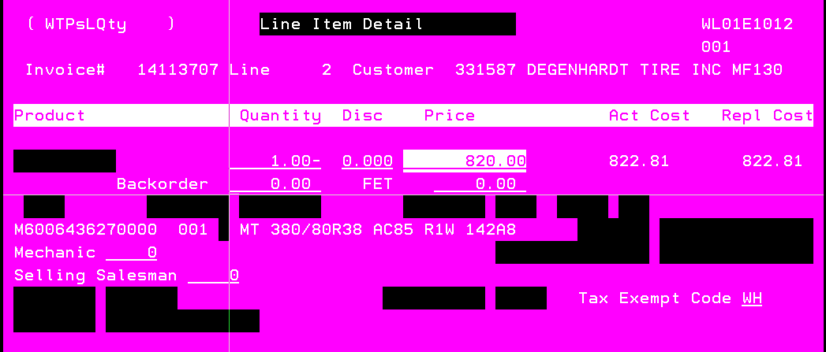

- Press enter when back to the main page of the invoice there needs to be three message lines one stating it is a new return credit, why it is being issued, and what the original purchase invoice was. To place a message line put an M on the line.

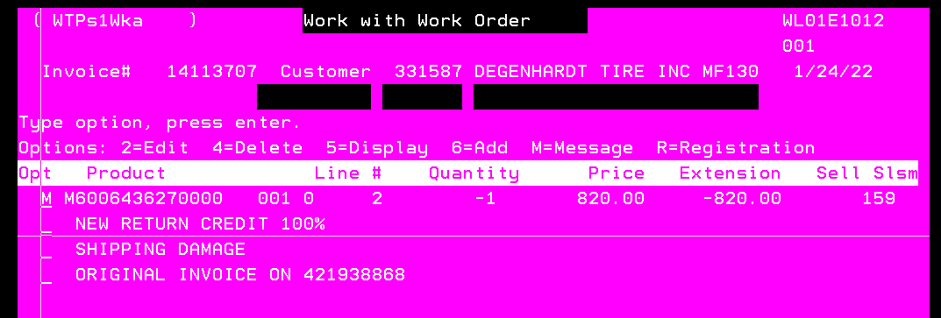
- From here press F3 and exit the invoice. The final step is going to be to ship the tires.

- Put an S on the invoice line press enter- F3-enter-enter and it will be invoiced out putting one into location 1 inventory. Since the tire is defective and it can’t be sold to another customer this will need allocated/added to 101092 once added an email need sent to the warehouse manager letting them know it needs added to wise hotspot-99.

How to look up invoices
Looking up invoices in madden-co allows anyone to view who did the original invoice and at what exact time. In adjustments this is used more for when the inbound tires are being checked in and there isn’t an extra copy for the records to check the tire in.
- From anywhere in madden-co press the Esc button this menu will pop up from here put a 1 on the invoice history inquiry then enter.
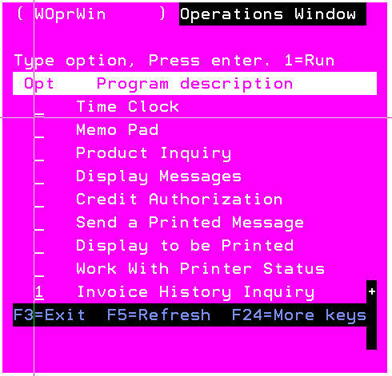

- Then enter in the location the invoice is based out of so invoice 421938868 is out of loc 42.

- Then press enter and input the invoice number, press tab then enter. The invoice should pop up to view the invoice. Put 5 on the line to print the invoice, put a 9 on the line then press enter.

How to look at inbound adjustments
Every warehouse should be filling out a computer paper trail of adjustments coming to Delphos. This helps determine how long an adjustment has left before it makes its way to location 1 or if the tire is held up at a different warehouse. If an adjustment transfer log is filled out that states that the warehouse is sending it out the day, it is being filled out. Depending on the warehouse it can then be determined how long the claim must go before it makes it to location 1.

- Go to the main page press 1-1-7-1.

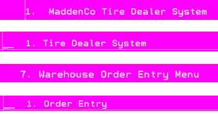

- Enter the location the tire was originally picked up at and sent out.



- Enter 101 for the customer number, it will always be 101 because it is going to location 1.

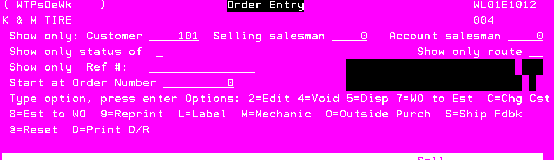

- Press F2 then go down to the product number line and enter ADJT for the product number.

- Press enter then put a C on the line.

- Press enter and all of the adjustments this warehouse has sent will pop up by putting a 5 on the line. It can be determined how long the tires have before they make it to loc 1.

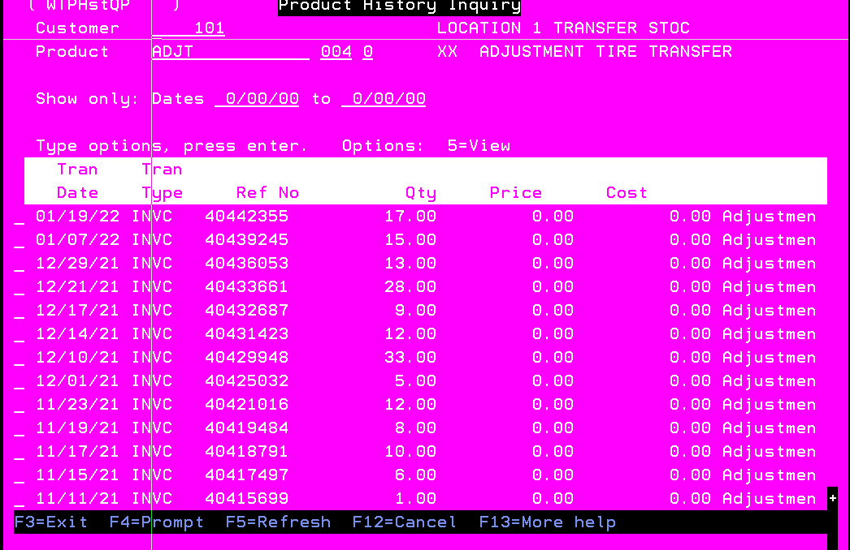

- If a tire isn’t on these transfer logs this means it should be in that warehouse. If a batch of tires comes in and they don’t have paperwork this is an easy way of reprinting.

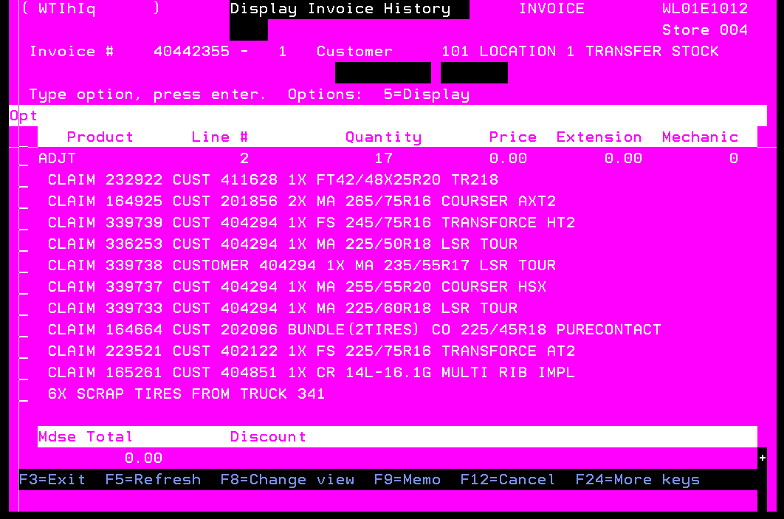

How to find the current cost of a tire
For specific claims the current vendor supply cost is needed in order to determine the credit for the dealer.
- Go to the main page press 1-1-7-1
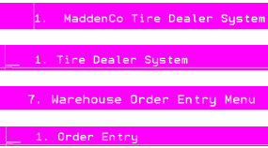

- Always go with location 1

- From this page click F2

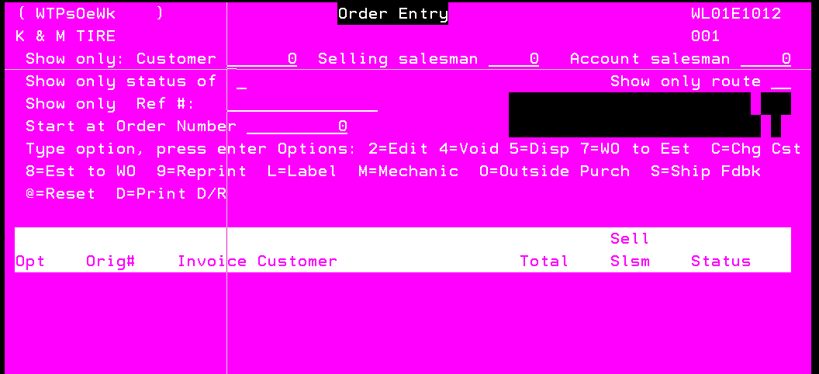

- Type in the product number

- Put a V on the line then click enter.
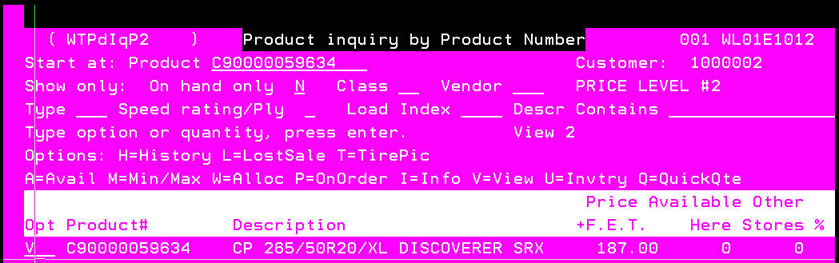

- The current cost K&M buys the tire will be the vendor supply cost.

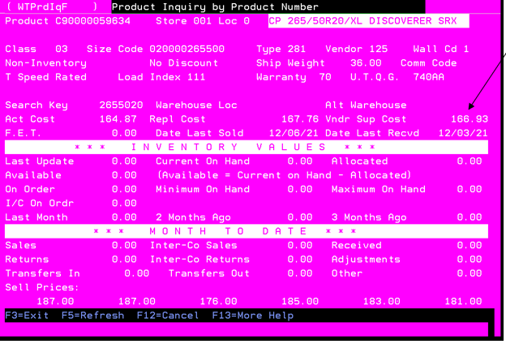

Weblink
Weblink is K&M’s online portal, it allows our customers to purchase tires online. As for adjustments, we use this to find the correct tire that was sent in for warranty. This will give you all the specs of any tire, wheel, tube, or part we carry in stock.

Weblink
- Use the link below.
  - http://weblink2.kmtire.com
  - Once there the User: demo1@kmtire.com Password: demo
  - Once logged in this page will pop up.
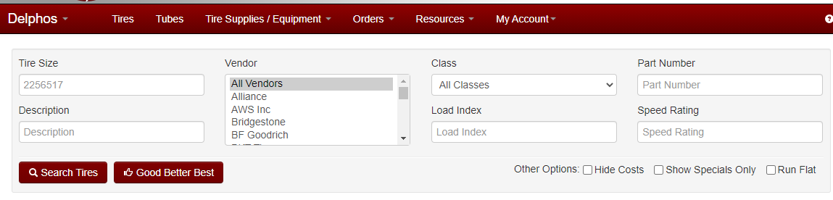

  - Here you can search based on size, tire description, class, part number, speed rating, vendor, or load index.
- When searching based on size don’t use / or R weblink will not take those.
Correct example:
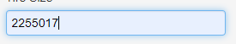
Incorrect example:
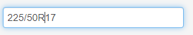
- If you want to find a specific tire the more information you have the more weblink will narrow it down. Now if multiple tires appear you will need to narrow it down based on the tire description, load index, and speed rating.

  - Once you search for the tire weblink will update and show you the results.

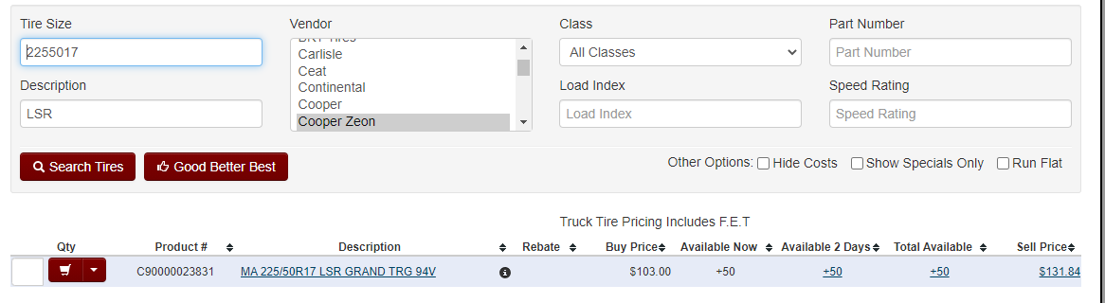

- You can click on the hyperlink under description and all the information for that tire will appear.
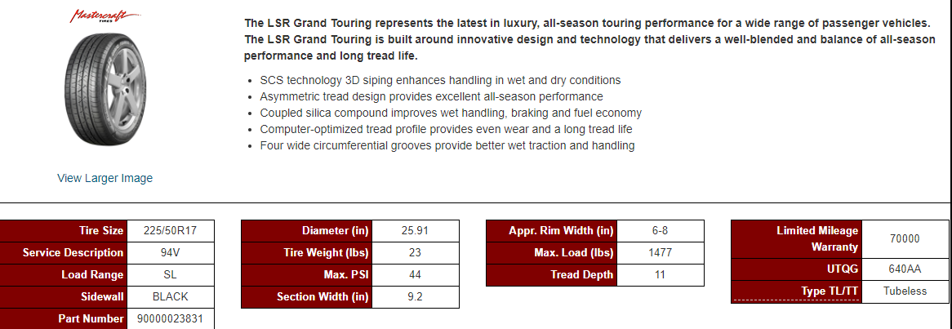
- Here is a complete overview of the tire. It will tell you what comes new with on the tread, color of the sidewall, the max psi, etc.
  - Another reason we use weblink for and this will be utilized the most will be for all the tire warranty guidelines.

Tire Warranty Information

- To find this information, you will need to go to the resources tab.

- You will need to scroll down to the warranty information tab. The next will pop up is this screen.
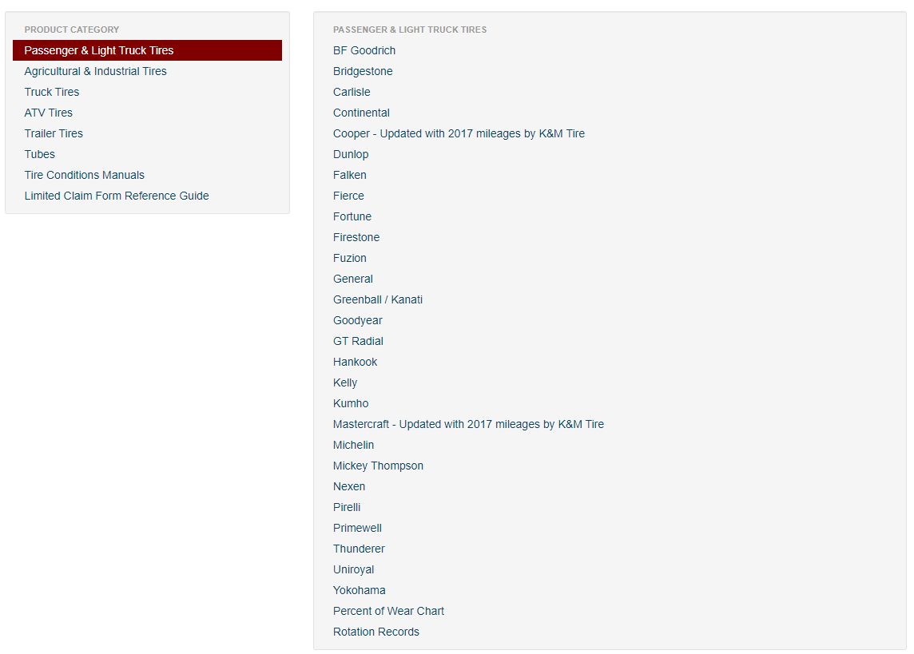
- This will have all the warranty guidelines for every class of tire. Once you click on the hyperlink it will show everything a specific vendor consider for a warranty adjustment.

SOP# 2
- Step 1
- Step 2
- Step 3

SOP #3
- Step 1
- Step 2
- Step 3

Inbound RAR

Inbound Adjustments
- Every day tires will come down from the transfer shift throughout the day, there is no set time for this.
- Every tire that comes down to adjustments should always have paperwork attached going with each tire. (BOL, On/Offs, Purchase history, rotation records)

  - An envelope should be attached to each tire, with the claim form number and the location written on the envelope to match what is on the transfer invoice.
  - Need to make sure we’re looking at the tire size, claim form number, or customer number.
  - Matching all that information up with the transfer invoice will ensure accuracy.
  - Claims filled out online should have the claim number written on each tire.
- If there is a tire that is missing from the transfer invoice, an email needs to be sent to every warehouse that the tire would have gone through on its way to loc 1 asking if the tire got held up.
- If a tire comes down with no paperwork and no information to go from. The tire then needs to be taken up to the warehouse office notify the warehouse manager.
- If a tire comes down with only a claim form attached to the tire all available information needs to be written down. We open the envelope and see what location this would be from and reprint the transfer invoice form Madden-Co.

RAR Adjustments
- Every Friday any tires that did not meet the warranty guidelines get sent back to the customer, but we could ship out daily if needed.
- Every tire that is getting sent out on transfer needs to have an invoice taped to the tire along with a RAR sticker with the location it is going back to written on the label. To create an invoice from Madden-Co for transfer items see below.
  - Log into Madden-Co
  - 1- Tire Dealer System, enter
  - 8- Point of Sale Menu, enter
  - 4-Counter Billing, enter
  - Store Number will always be the store you are in (Ex. Delphos- Store 1) Field Exit, Enter
  - F6- Starts a new invoice.
  - F6 again Assigns an invoice number.
  - On the customer number line, F4 allows you to do a search. For all K&M
locations search by using ZZZLOC, enter. Page down until you find the location you are shipping to. Always choose the account for that location that says Transfer Stock.

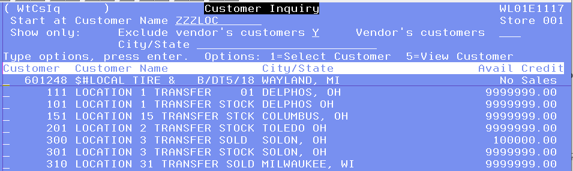
  - Place a 1 on the line in front of the account you want to choose. Field Exit, then Enter. Enter again.
  - It will then ask for you Sell Salesman number. This is your salesman number you were assigned by IT when you started at K&M. If you do not know what it is, IT can help you with that. Field Exit and Enter.
  - Product Code will be “BOX” Field Exit, Enter
  - Quantity will be 1, Field Exit and tab down to the Description Line and edit it to say what is in the box. Field Exit and Enter.
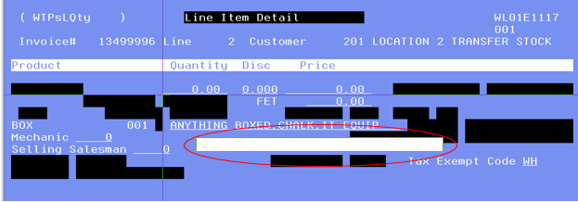
- Each RAR gets one invoice taped to the tire, and two others of the same invoice stapled together. When we take the RAR’s up to stage, in the warehouse manager’s office there are trays sorted by region. All invoices should be put in the appropriate region that the tire is going back to.
- When the tires are brought down, please use this spreadsheet to view the correct corresponding door with each location. This can be found in the F Drive under F:\Adjustments\Public\RAR Procedure

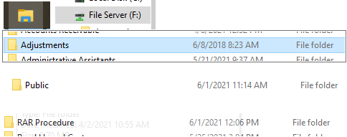

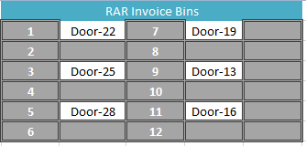

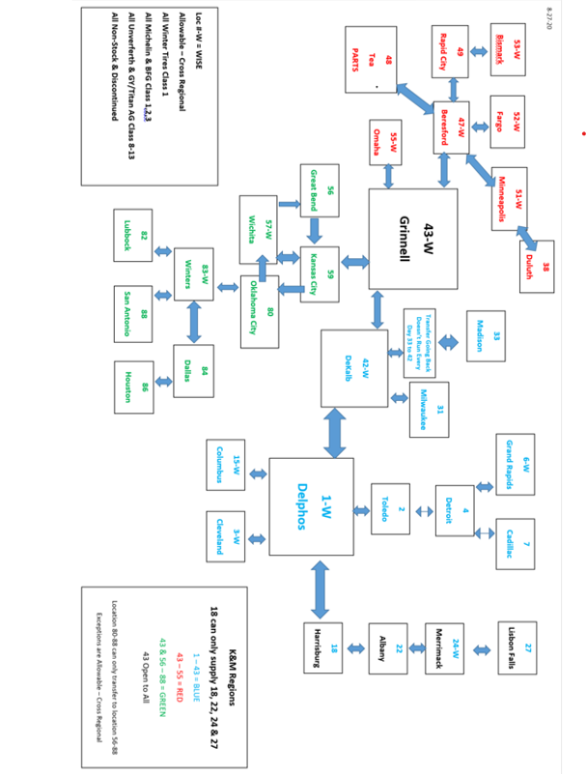

SOP #3
- Step 1
- Step 2
- Step 3

Inbound Defects and Mis tags
- Every day tires will come down from the transfer shift throughout the day, there is no set time for this.
- Every tire that comes down to adjustments should always have the BOL going with each tire.
  - An envelope should be attached to each tire, with the claim form number and the location written on the envelope to match what is on the transfer invoice.
  - Confirm the tire size, claim form number, or customer number.
  - Matching all that information up with the transfer invoice will ensure accuracy.
- The receiving warehouse needs to verify the tire is in LOC 1 before adding the tire onto 101092, based off paperwork only.
- Tires with no paperwork and no information should not be brought down to the adjustment department.

Field Adjustment
Sometimes it is necessary for salespeople to have the vendor send a rep directly to the customer to examine tires. This is known as “a field adjustment” or “a claim done out in the field”.
- The salesmen needs to let the adjustments team know that this is being done by either a phone call or email. When the adjustment team member is notified they start the process below.
- The adjustment team will then process the claim as “PENDING” in the portal. 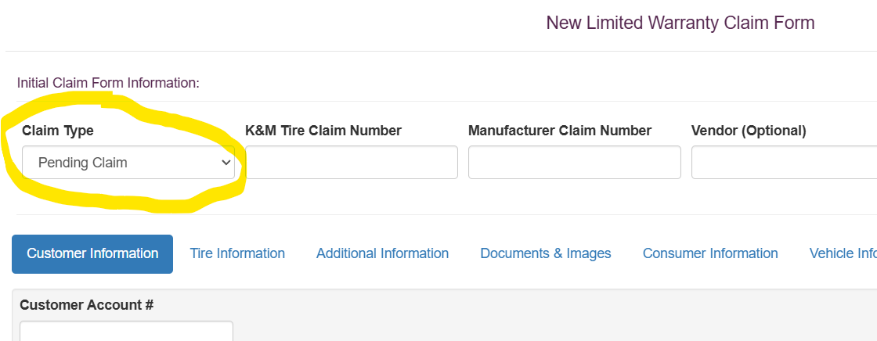
- All known documents, pictures, and information should be added to the claim on the portal which should be supplied by either the salesperson or vendor representative.
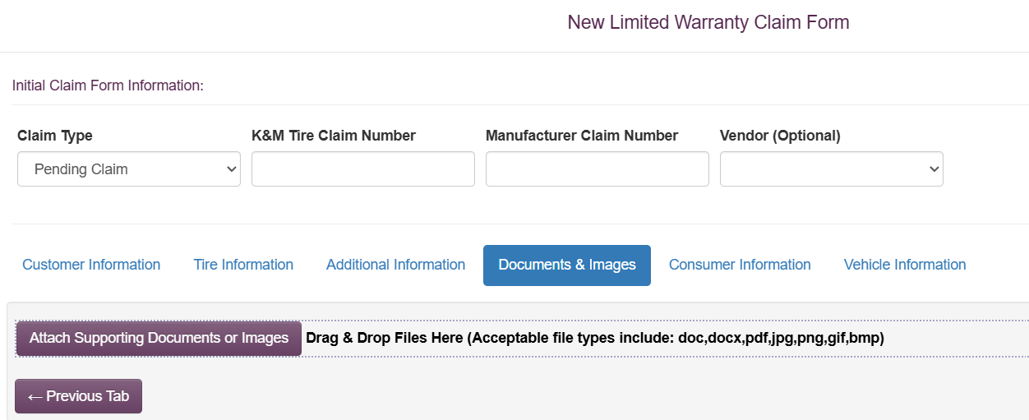
- Make note that the claim is “a field adjustment”. 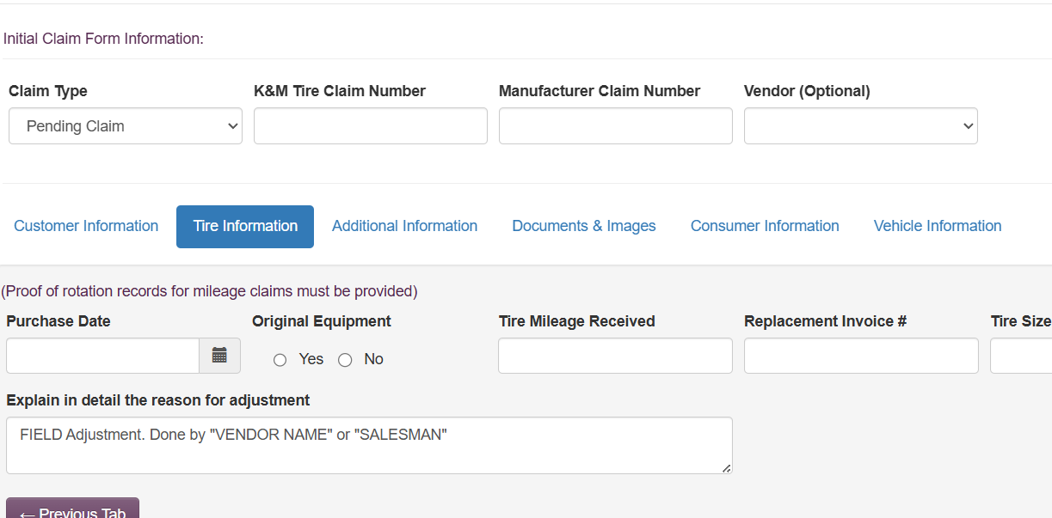

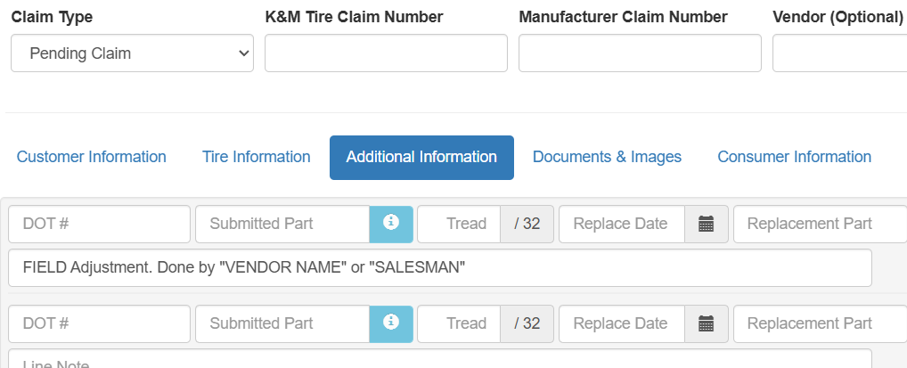
- Do not pass credit onto the customer until only after K&M tire receives the credit memo from the vendor.
- Once we receive credit from the vendor, the claim can be changed to “MISCELLANEOUS”, and the credit can then be applied.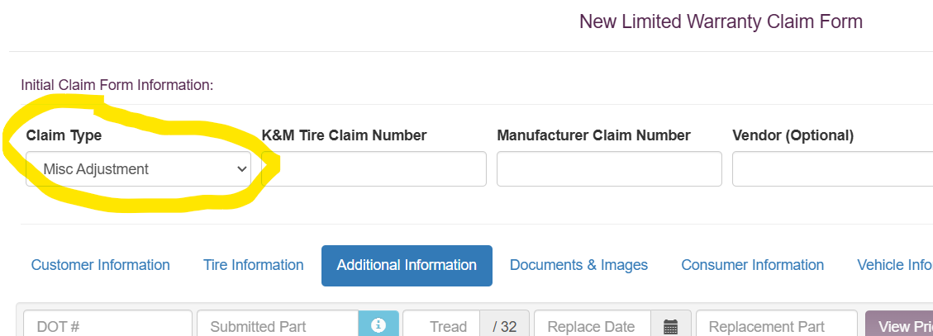
- Email the credit memo and the claim number to A/P invoices (invoices@kmtire.com) to match in tracking and close out the claim.
- If the credit of the claim is over $700, please have another person verify the credit amount.

K&M Road Hazards
The K&M Tire Road Hazard program constitutes an offer between K&M and the dealer. The program promises prorated road hazard coverage on all non-commercial, no-trailer use passenger and light truck replacement tires purchased from K&M Tire in the event of a tire failure due to a no-repairable road hazard, workmanship, or materials defects for the usable life of the original tread.
Dealers must be enrolled in the K&M Tire Road hazard program on the date the eligible tire was originally purchased from K&M Tire. There are two ways to check to see if a dealer is enrolled in this program.

First Option K&M Road Hazard Master List
- Open the F-Drive.
- Go under Adjustments select Public.
- Scroll down to Road Hazard Customers.
- Master list-Eligible Road Hazard Customers.
  - If this list doesn’t show them, it is more than likely they’re not on the K&M Road Hazard program and the tire cannot be processed (it would become an RAR claim)
The second option is through Madden-CO entering 1-1-7-1
- 1. Madden-Co Tire Dealer System
- 1. Tire Dealer System
- 7. Warehouse Order Entry Menu
- 1. Order Entry
- Enter the Store Number to be Used: 001 (choose the location you are searching)
- Show only: Customer 101485 (enter customer number) press F2.
- To display by PRODUCT NUMBER: enter product number Enter “RH, RH2, or RH3 and hit enter.
- A new screen will populate and once it does hit “C” on any of the line and hit enter.

  - This will be the final screen and from here you be able to tell if they pay the road hazard fees and the credits the dealer has in their account. For road hazard anything with -1.00 is a credit and anything positive is a bill, and the monthly fee $75.00 a month so this customer would have road hazard.
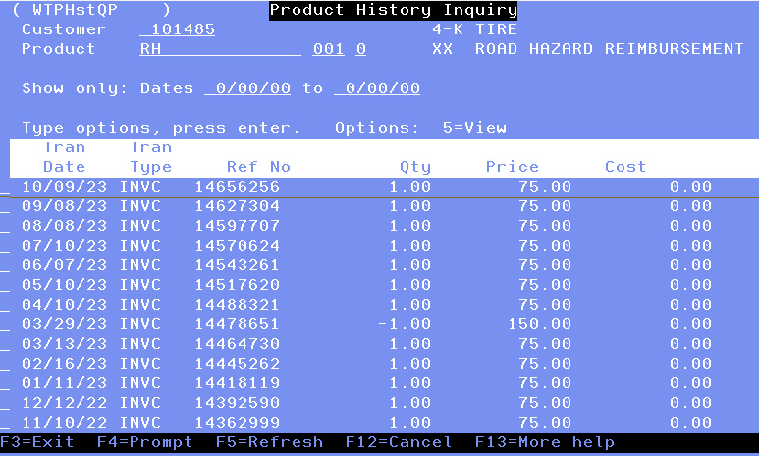

Documentation
- The customer must provide on/off invoices.
- The invoices provided must be no more than 3 years apart from installation date and removal date.
- The customer must purchase AND replace the tire with K&M. (original tire and replacement tire must be bought from K&M.)
- The tire is covered down to the last 2/32s of tread.

Processing the claim
- Visit http://intranet.kmtire.local/index.php?area=adjportal
- Log in using your username and password that will be provided.
- Click on Adjustments – Adjustment Portal




- Start a new claim. Claim type needs to be Road Hazard. This is essential because the road hazard claim type limits the credit amount to $150.00 per tire. (This is the max K&M offers per tire when submitting for a K&M road hazard.)

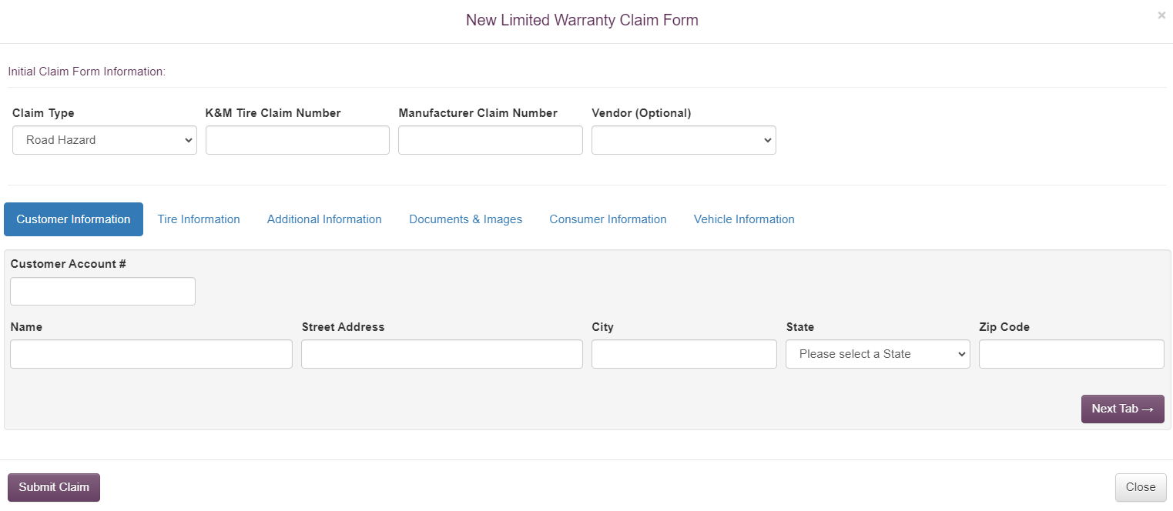
- K&M Claim number and the Manufacturer Claim number will both be the same. This will be the claim number on the claim form the customer submitted.
- The Customer Account number will simply be the customers number that submitted the claim.
- The tire information section will be filled out accordingly. The purchase date will be the date the claim is being processed on.

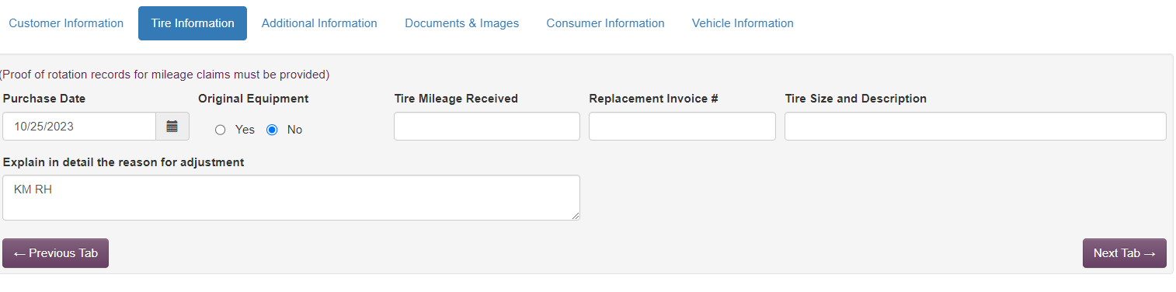

- The additional information tab needs completed accordingly.
- The DOT section does not need to be filled out.
- The correct part number needs inserted.
- The tread depth box needs to be changed to whatever tread depth reading was taken.

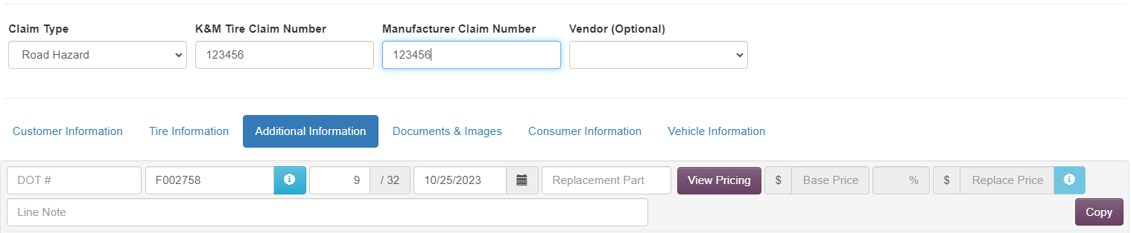
- Once the tread depth is changed, view pricing needs to be selected. This will bring up the customers purchase history of the tire.
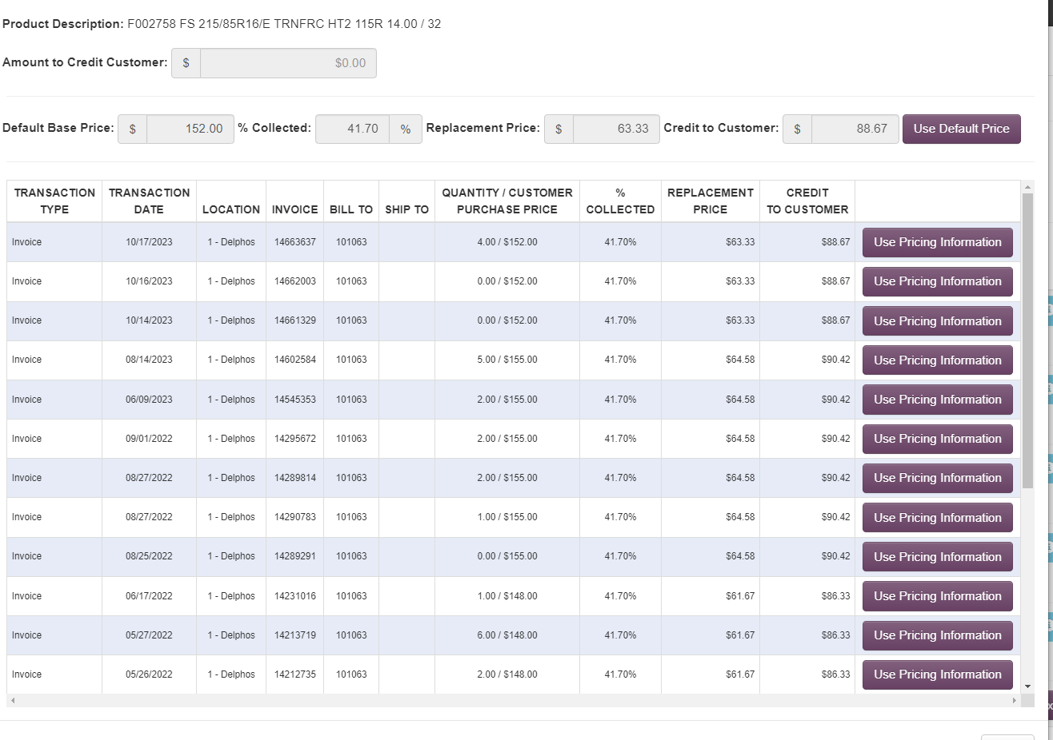
- Use the pricing information that is closest to the original purchase date of the tire provide one the “on” invoice.
- Once pricing information is chosen, close that box.
- This will auto fill the credit amount.
- To see the amount the customer is receiving, click the blue box with an “I”. This amount should never be over $150.00.
- The line note should read “KM RH (credit amount)”

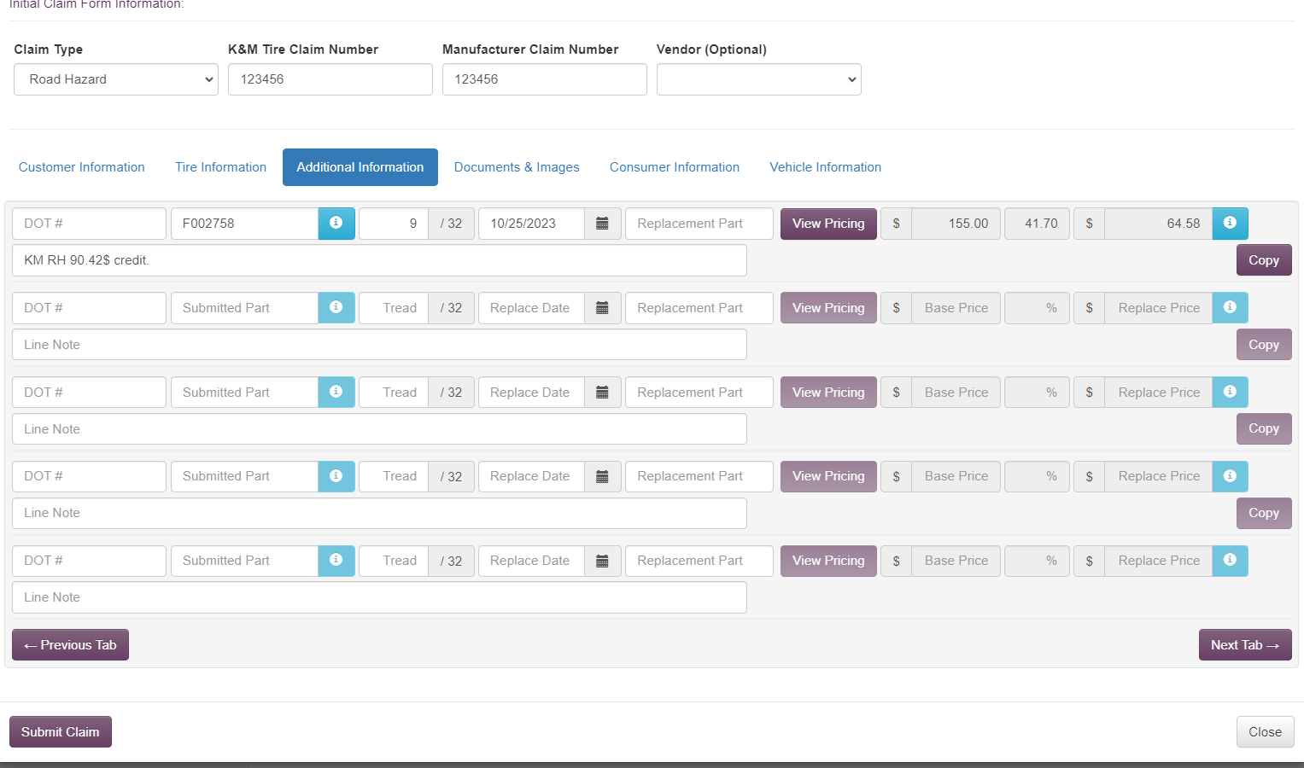
- Next upload the documents and images.
- Once this is completed, the claim can be submitted, and the tire can be scrapped.

- SOP# 2
- Step 1
- Step 2
- Step 3

SOP #3
- Step 1
- Step 2
- Step 3

Hankook PLT

Hankook PLT Warranty
- Make sure that tire falls under the guideline to view these click the link https://www.tireimages.com/warranty/passlt/hankook.pdf
- Make sure all necessary documentation us acquired,
- Clear the estimate out of the system.
- Begin the claim in the intranet portal follow the steps from the intranet section.
- Fill out the Hankook warranty form.
  - This can be found under the F:\Adjustments\Public\Adjustment Vendor Procedures\Hankook Adj Procedures\HANKOOK CLAIM FORM TEMPLATE.pdf form template most recent spreadsheet.

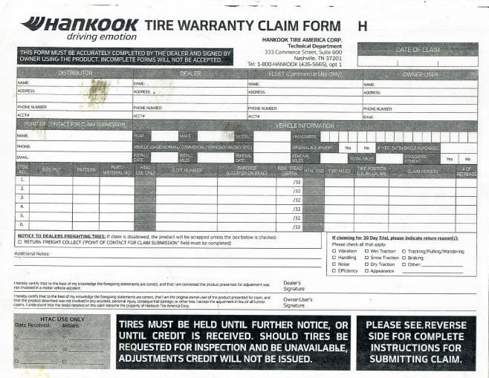

- Top right- H number will be the manufacturer claim number used in the adjustment’s intranet portal.
- Date of Claim Box will be the date the claim is being processed.
- Distributor Box this will be K&M’s information.
- Dealer Box this will be K&M’s customer that the credit is being issued to.
- The Fleet box can be left blank and is never used by us.
- Owner-User Box this can be left blank, however if K&M’s customer provides the end users information, it can be entered in this box.
- Point of contact for claim submission this box can be left blank.
- Vehicle information- Everything in this section needs to be completed, the only section that can be left blank is the VIN number.
- Size/ply this will be the specs of the tire that is being used.
- Pattern this will be the pattern of the tire. Example.) Kingery ST H735. H735 will be the Pattern.
- Part/ Material NO. this is the tires Part Number.
- DOT this is the full DOT of the tire.
- Barcode this can be left blank.
- REM. Tread depth this is the tread depth that was recorded while processing the claim.
- Tire miles is the number of miles the customer put on.
- Tire position this can be left blank.
- Claim reason this is the reason the tire is being processed for warranty.
- # of retreads this can be left blank.
- Additional Notes used to explain further in detail the warranty reasoning.
- Dealer Signature and Owner-User’s Signature these two-need signed by the individual that is processing the claim.

  - Once the claim form is finished and the claim is submitted in the Intranet portal, the information needs to be entered in the appropriate spreadsheet.

  - This can be found by going to F:\Adjustments\Public\Adjustment Shipping 2.0\16-Hankook (Being Shipped)/Excel (Spreadsheet number).

  - The tire needs a label tapped to it with the manufacturer claim number and staged in the outbound shipping area.

The Warranty Guidelines
When it comes to giving 100% credit for a tire for a tire pro-rata the tire based on the tread depth remaining on the tire. If the tire is new within the first 2/32’s and first year of any manufacturer defect it covered at 100% credit. If the tire is not within the first year it may be pro-rata up to 6 years after the sixth year the warranty is voided.

- Out of Round- Any sort of ride disturbance Ex.) Vibration, Noise, Pulling
  - Must be within First Year of installation.
  - Must be within First 2/32s of treadwear.
  - Only two tires or less can be submitted for this warranty.
  - All PLT tires are included in this warranty.
  - If DOT is within a year from the date the claim is being processed, then documentation is not required although it is still preferred.
  - The warranty is covered at 100% credit.

- Road Hazard- Any foreign object creating a clear puncture in the tire making the tire unserviceable.
  - Must be within First Year of installation.
  - Must be within First 2/32s of treadwear.
  - Must be a clear puncture that is nonrepairable.
  - For tires that are covered under this warranty go to F:\Adjustments\Public\Adjustment Vendor Procedures\Hankook Adj Procedures\Hankook Warranty Matrix_2023(1).pdf This will show all tires that have road hazard coverage.
  - The warranty is covered at 100% credit.
- 30 Day Buy and Try-Customer satisfaction trail period.
  - 4-6 Tire are allowed to be substituted.
  - 1-3 Tires are not eligible for this warranty.
  - Must be free of any damage due to misuse, road hazard, Mechanical wear etc.
  - The warranty is covered at 100% credit.
  - *On/Off invoices are required. Invoices must be no more than 30days apart.
  - For tires that are covered under this warranty go to F:\Adjustments\Public\Adjustment Vendor Procedures\Hankook Adj Procedures\Hankook Warranty Matrix_2023(1).pdf. This will show all tires that are covered under the 30-day warranty.

- Mileage- A tire worn down to 4/32s or less before the guaranteed warranty miles.
  - Must provide installation records, tire rotation records, and removal record.
  - Vehicles with staggered tire sizes will receive half of the guaranteed warranty miles.
  - Must be free of any damage due to misuse, road hazard, Mechanical wear etc.
  - OE tires are not covered under this warranty.
  - For tires that are covered under this warranty go to F:\Adjustments\Public\Adjustment Vendor Procedures\Hankook Adj Procedures\Hankook Warranty Matrix_2023(1).pdf. This will show all tires that have the milage warranty.
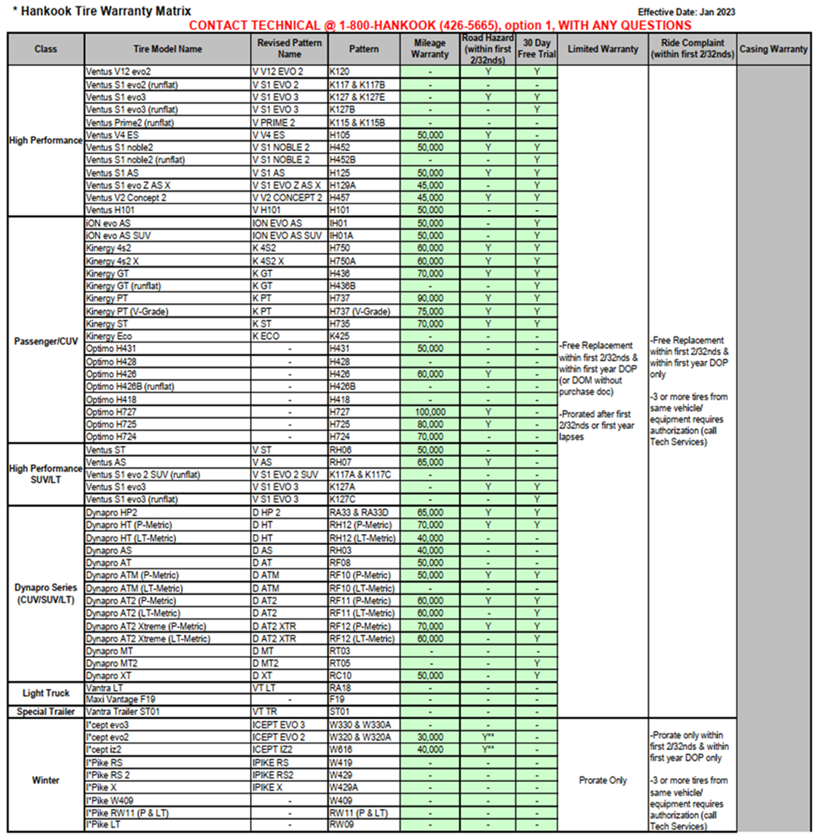

Conatact for Hankook Warranty:
Daneil Brown
Daneil.Brown@hankooktech.com
Warranty.support@hankooktech.com
empire@rxo.com – Shipment Spreadsheet
Hankook warranty call center: 800-426-5665

SOP# 2
- Step 1
- Step 2
- Step 3

SOP #3
- Step 1
- Step 2
- Step 3

Cooper/Mastercraft PLT
- Make sure that the tire falls under the guidelines to view these click this link https://www.tireimages.com/Warranty/PassLT/Cooperbrands.pdf
- Make sure all necessary documentation is acquired.
- Clear the estimate out of the system.
- Begin the claim in the intranet adjustment portal follow the steps from the intranet section.
- Open the Cooper/Mastercraft spreadsheet and fill out the correct information.
  - This can be found under the F Drive/Adjustments/Public/Adjustment Shipping 2.0/18-Cooper-Mastercraft-Roadmaster (Not Shipped) Open the excel sheet.

Filling out the spreadsheet
- Ship to party is always going to be 229303 and this will never change on any of the spreadsheets.
- Control number will only change when there is a new spreadsheet. In the example below the number is 992507 and when there is a new spreadsheet it will be 992508.
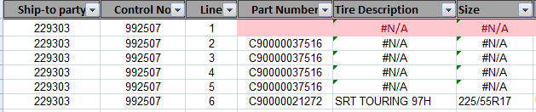
- Line is the number of row, and this information is for NAB Supervisor (Emily) so she is able to match this up later on
- Part number is for the tire part number.
- The tire description and tire size will generate automatic once you enter the part number.
- DOT number can be found on the sidewall of the tire. U93L is the DOT on this tire.

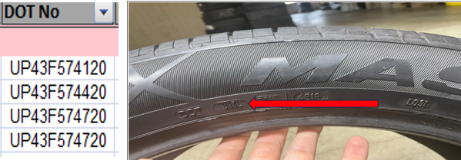

- Press loc can be located after the DOT, in this example it would be LO3L.

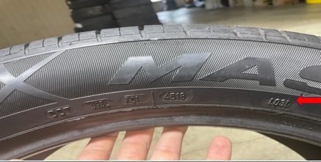

- The barcode is located on the sidewall of the tire. You will be able to scan it into the spreadsheet and if its worn-out NA (not available) can be entered.
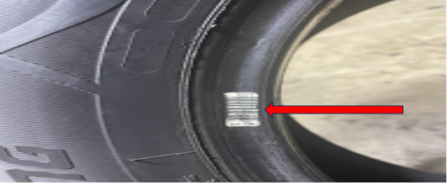

- The splice can be found on the inner liner of the tire. Put a (1) for a single stage and (2) for a two-stage tire.

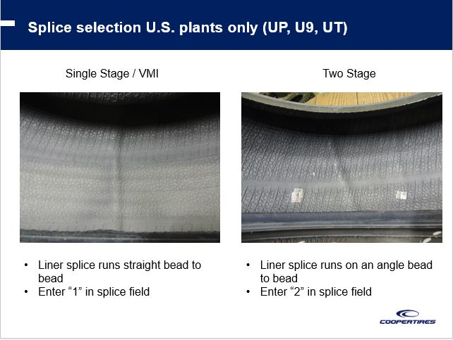
- Return reason will have a drop-down selection to choose from. These are the warranty codes that will meet the guidelines.
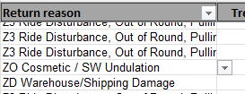

- The tread depth needs to be at the current tread depth of the tire.
- Mileage is the amount of mile the tire was driven on. If this information was not provided, then use your best judgment most PLT tires last between 5,000 – 8,500 miles per 1/32s.
- Date of purchase is when the tire was purchased.
- The last few sections are very basic and about the dealer.
  - Consumer name
  - Consumer address
  - Consumer phone number if provided, if not enter “N”.
  - Premium docs would be purchasing replacement history.
  - Authorization number if one is provided, if not enter “N”.
  - Note if anything additional needs to be added the Cooper should know.
  - The credit amount is what is being paid back to the customer.
  - K&M invoice number will need to be entered. This can be found once the claim is submitted.
  - K&M location is the location the claim came from

- Each tire needs the manufacturer claim number tapped to it, then the tire needs placed on the tire rack. Any paperwork provided with the claim needs to be saved.

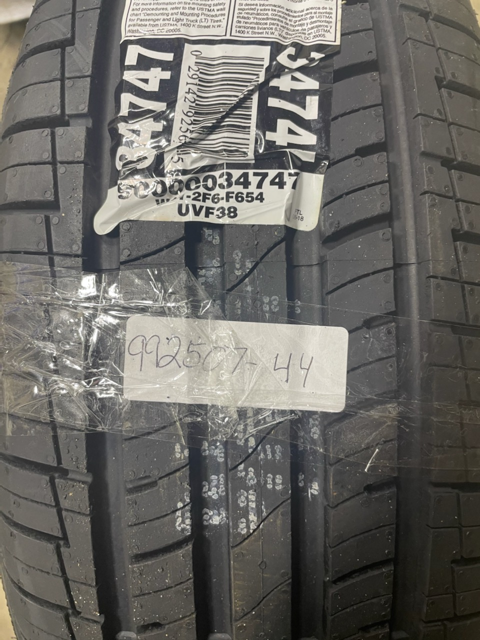

- The excel spreadsheet needs to be sent to David_schwab@goodyear.com once a week. David will instruct you on whether to scrap the tires, or to ship them back to the manufacturer.

The Warranty Guidelines
- 45 Day Test Drive- This allows you to submit the set of 4 tires for 100% credit.
  - Must have purchase and replacement invoice that are within a 45-day time frame.
  - There is no tread depth limit for this warranty,
  - Tires cannot have any damage caused from road hazard, misalignment, abuse, or any other outside causes.
  - This warranty covers any disturbance, shaking, vibration, pulling, etc.

- Road Hazard- No Cooper/Mastercraft product has a Road Hazard warranty unless pre-authorization is given by Cooper/Mastercraft.

- Out Of Round- Up to 4 tires can submitted for Out of Round policy.
  - Must be within first 2/32s of tread wear.
  - 1-4 tires can be submitted for this warranty.
  - Tires cannot have any damage due to misuse, Road Hazard, Alignment issue, or mounting damage.
  - 100% credit will be issued for this warranty.
  - Invoices are not required.

- Manufacturer defect-Anything tire defect that is caused by manufacturer issue.
  - Conditions such as Ply gap, wild wires, molding defect, sidewall bulge, tread separation, etc.
  - If tires are within the first year and first 2/32s, tires will be covered at 100% credit.
  - If DOT is within a year, no invoices are needed.
  - After the first year, or first 2/32s of treadwear, tires will be pro-rated based off remaining tread depth.

- Mileage- Premature treadwear before guaranteed miles are received.
  - Must provide on/off invoices including rotation records.
  - Tires must be rotated every 8000miles or less.
  - Covered down to the last 1/32 of treadwear.
  - Must be 4/32s or less remaining of warranty.
  - Tires must be free of any damage.
  - Tires must be worn evenly across the tread face. No more than 1/32 difference between tread depth readings.
  - Tires will be pro-rated based on remaining tread depth and the number of miles received.
- Ozone/Water cracking- Cracking on the sidewall or tread of tire.
  - Tires are covered up to 4 years from DOT date.
  - Within the first 2/32s and first year, tires are covered at 100%
  - Anything after the first year or first 2/32s tires will be pro-rated.
Contact for Cooper/Mastercraft:
David Schwab
David_schwab@goodyear.com
Cooper/Mastercraft call center: 800-854-6288

SOP# 2
- Step 1
- Step 2
- Step 3

SOP #3
- Step 1
- Step 2
- Step 3

Falken PLT
- Make sure that the tire falls under the guidelines to view these click this link https://www.tireimages.com/Warranty/PassLT/Falken.pdf
- Make sure all necessary documentation is acquired.
- Clear the estimate out of the system.
- Begin the claim in the intranet adjustment portal follow the steps from the intranet section.
- Fill out the Falken form. This can be found under the hyperlink above.

  - Tab 1 will require the dealer’s name and address, which will be K&M information.
  - Tab 2 will require the Associate dealer’s name and address information.
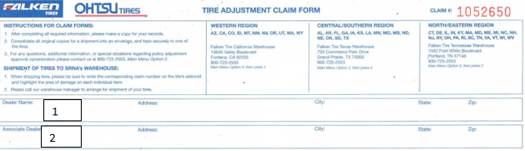
  - Tab 3 will be information about the tire. Such as size, tread design, the DOT #, tread depth, tire mileage, adjustment reason, and vehicle information.
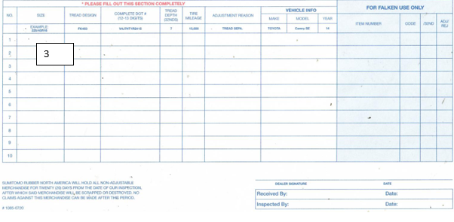

- Once the claim form is finished and submitted in the intranet adjustment portal, the documentation that is provided needs to be stapled to the Falken claim form and placed in the outbound adjustment’s cabinet. A label with the manufacturer claim number needs tapped to the tire, and the tire needs placed in the shipping area in the correct rack.
- Once the above steps are done you need to enter information in the correct spreadsheet. This can be found going to F-drive/Adjustments/Public/Adjustment Shipping 2.0/Falken/The excel file at the bottom.

The Warranty Guidelines
- Road Hazard
  - Tire must be within first 2 years and first 3/32s of treadwear.
  - Documentation is required unless DOT date is not in rage.
  - OE tires are not covered under this policy.
  - The warranty is for 100% credit.
  - The below tires are covered under this warranty.

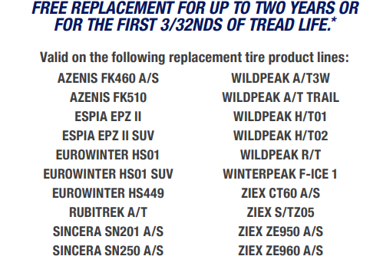

- Manufacturer Defect

  - Any defect in the tire is caused by the manufacturer.
  - This includes but is not limited to ply gap, wild wires, tread separation, sidewall cracking, etc.
  - If within first year and first 2/32s tire will be covered at 100% credit.
  - If tire is past the first year, or worn more than the first 2/32s, then the tire will be pro-rated.
  - Documentation is not required but is helpful for showing time in service.

- Out of round
  - Up to 2 tires can be submitted for this warranty.
  - Must be within the first year and first 2/32s for coverage.
  - Documentation is not required unless DOT is not within a year.
  - Tires must be free of any damage not caused by the manufacturer.
  - This warranty is 100% coverage.

- Mileage
  - Tires must be worn down to 4/32s or less.
  - Once tires get below 2/32s, mileage warranty is no longer covered.
  - Must have on/off invoices and rotation records.
  - Rotations must be at or before every 8000 miles.
  - Must be evenly worn across the tread face.
  - Anything greater than 1/32 difference in tread reading will void warranty.
  - Must be free of any road hazards, bead damage, or any other damage outside of the manufacturer’s control.
  - The below tires are covered under this warranty.

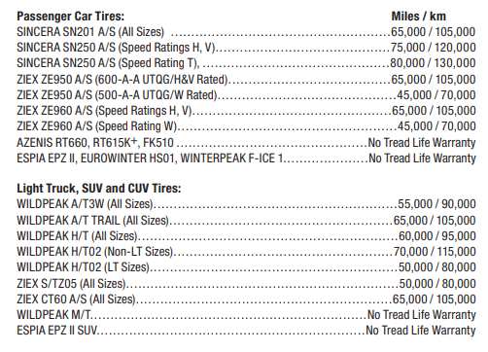

- 30 Day buy and try:
  - 4 tires can be submitted for this warranty.
  - Must have invoices showing tires were installed and removed within 30 days.
  - Tires must be free of any damage.
  - Tires can have no more than 1000 miles of use.
  - A customer satisfaction survey must be completed for this claim.

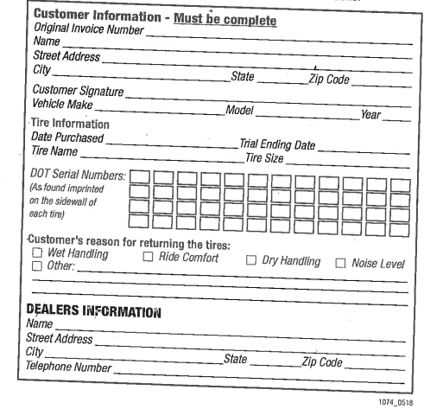

Contact for Falken:
Warranty@srnatire.com
Falken Call Center – 800-723-2553

SOP# 2
- Step 1
- Step 2
- Step 3

SOP #3
- Step 1
- Step 2
- Step 3

Goodyear & Kelly PLT

Goodyear/Kelly ADJ Procedures
- Make sure that the tire falls under the guidelines to view these click this link https://www.tireimages.com/Warranty/PassLT/goodyear.pdf
- Make sure all necessary documentation is acquired.
- Clear the estimate out of the system.
- Begin the claim in the intranet adjustment portal follow the steps from the intranet section.
- Open the TireHQ and login to fill out the correct information.
http://apps.tire-hq.com/thq/home/home.htm?tasks=Y

  - This will be the homepage, click TRANSACTIONS.
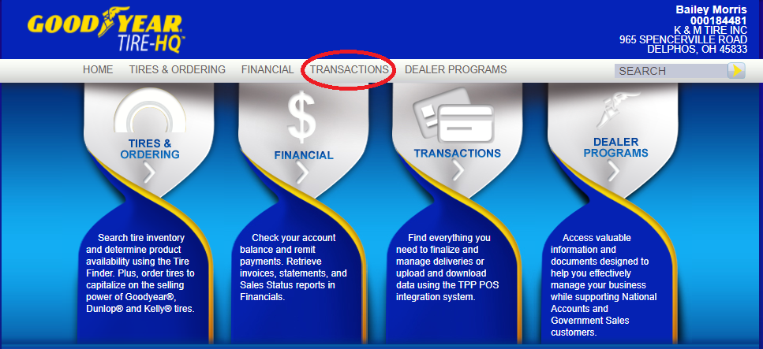

  - Click on the S- Adjustment Document

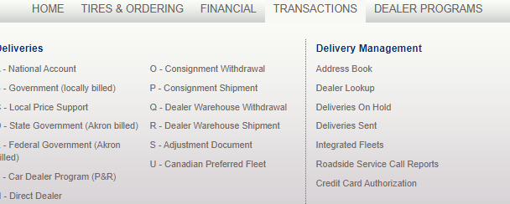
- The adjustment Document Claim number will be the K&M claim form number. Claim date is the day the claim is being processed. Customer information box does not need filled out, select your vehicle can be left blank, however if the information is provided it should be entered. Special information does not need completed.

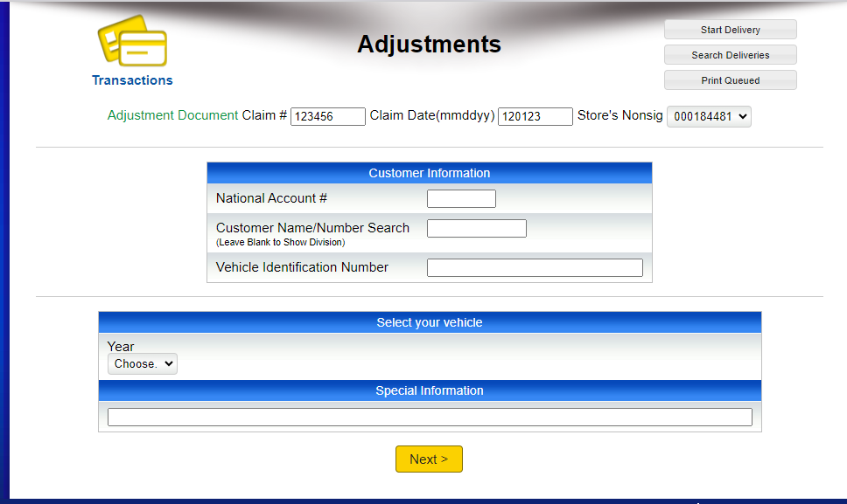

- This next section needs to be filled out with the K&M customer’s information that is submitting the tire for warranty. Phone Number and Email box does not need completed.

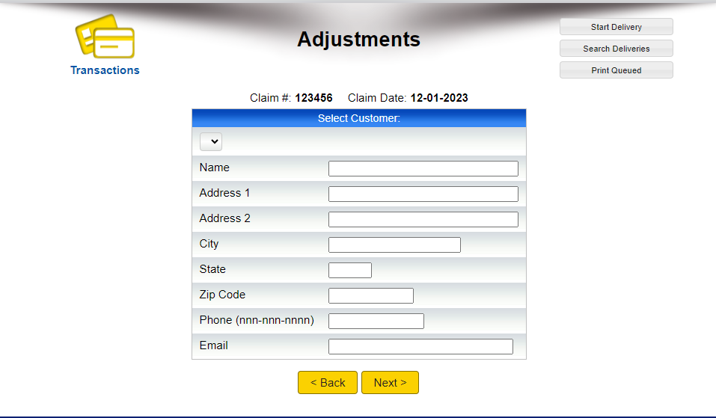

- The fourth section is going to ask for the part number once entered the size, weight, and original tread depth will auto fill.

- Replacement invoice # type in NONE in this box if it is not provided. Next is the current tread depth, in this box put the tread depth that was recorded when the measurement was taken. The replacement price is what the customer had to pay to get the replacement tire. So, if the credit issued amount is 100%, then the replacement price would be $0.00. This is because the customer did not have to pay any money out of pocket to get a replacement. Now if the tire must be pro-rata, and we issue a credit of 70% on a $100 tire then the replacement price is $30.00. This is because we gave the customer 70% (or 70$) and they still must pay 30% (or 30$) to get a replacement tire. If there is no approval number, simply put none.

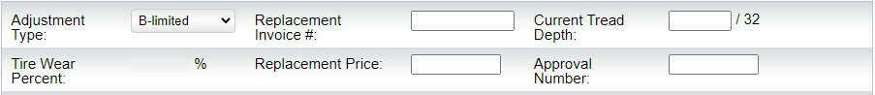

- The mileage is not provided use best judgment for how many miles the tires should have (do not leave mileage blank). Now if the claim is specifically for Mileage, you must have rotation records proving the exact mileage the tires endured.
  - Mileage is the number of miles the tire was driven on. Most passenger and light truck tires last between 5,000-8,500 miles per 1/32s.
  - If the wheel position is unknown other can be entered. It will also ask for the reason for the adjustment select the option for the claim. The comment section can be filled with any line notes (not required).

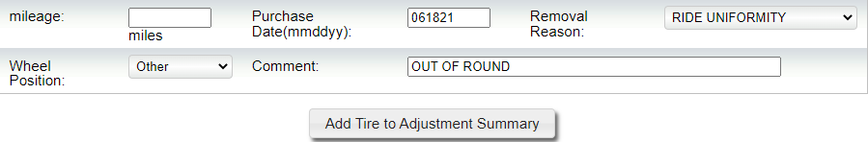
- Once all the information is entered click add tire to adjustment summary. It will have all the information on this line. If there is multiple tires for a claim fill in the information again and click add tire to adjustment summary.

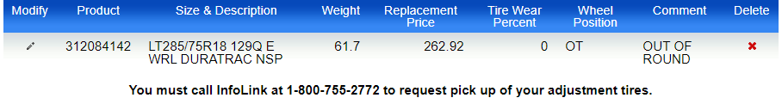

  - Once all the tires are added click send and queue adjustment

- After that, click the top right “Print Queued”. A pop-up will appear, and two copies need to print off. Use a small label to write the K7M claim number down and tape it to the tire. Staple the two printed copies together with any paperwork that was submitted and place them in the outbound adjustments folder.

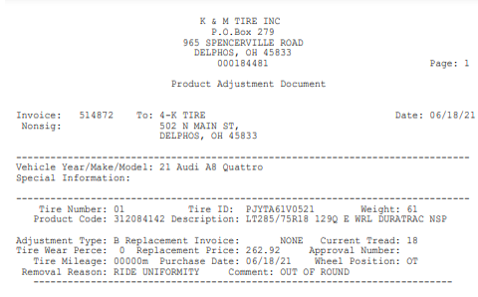

- Next Grab an Adjustment tire label and fill it out as follows. The FROM section will be the KM business stamp. For customer/Nonsig #, this can be found in two places. At the top right of the Goodyear Homepage, or at the top of the two copies that were printed out in the previous step. (Circled in the pictures below). Next is the Line number, this is the amount of tires on the claim. If there is 1 tire, then write 1 0f 1. If there are 4 tires for this claim write 1 of 4, 2 of 4, 3 of 4, 4 of 4. * Note: If there is more than 1 tire for the claim, each tire needs its own individual Adjustment tire label.

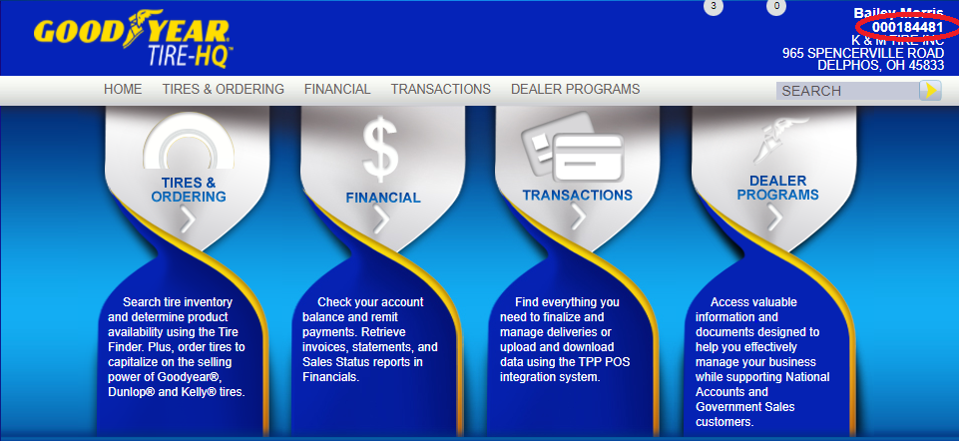

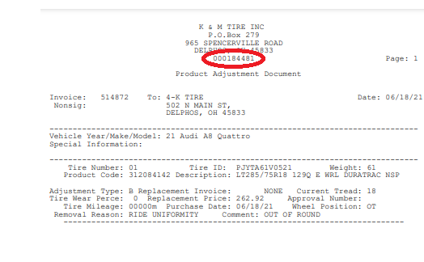

- All paperwork needs to be in the outbound folder after the claim is submitted on the intranet. The same information needs to be entered in the Goodyear shipping spreadsheet in the F drive (F-drive, Adjustments, Public, Adjustment Shipping 2.0, 14-Goodyear-Kelly (Being Shipped). Lastly, place the tire in the in the correct shipping bin.

The Warranty Guidelines
When it comes to given 100% credit for a tire or pro-rata the tire based on the tread depth remaining on the tire. If the tire is new within the first 2/32s and first year ANY manufacture defect it covered at 100% credit. If the tire is not within the first year it may be pro-rata up to 6 years after the sixth year the warranty is voided.

- Out of round
  - Must be within First Year of installation.
  - Must be within First 2/32s of treadwear.
  - Only two tires or less can be submitted for this warranty.
  - All PLT tires are included in this warranty.
  - If DOT is within a year from the date the claim is being processed, then documentation is not required although it is still preferred.
  - The warranty is covered at 100% credit.
- Road Hazard
  - Goodyear/Kelly does not offer a Road Hazard warranty.
- 60 day (Goodyear) 45 day (Kelly) Buy & Try
  - Select Goodyear tires must be replaced withing 60 days of installation.
  - Select Kelly tires must be replaced within 45 days of installation.
  - Tires must be free of any damage when returned.
  - Must replace it with a Goodyear Kelly product.
  - Must provide installation and removal invoices.
  - Only the originally purchased tires are covered. The replacement tires are not.
  - Tires must also be within the first 2/32s of treadwear.
  - Below are the tires covered under this warranty.

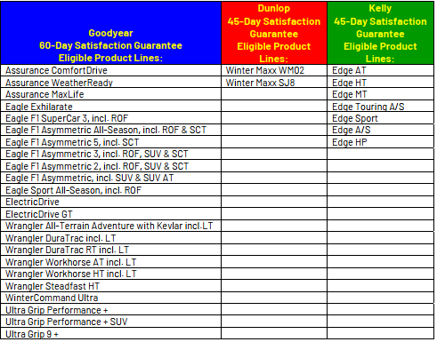
- Mileage
  - Must provide installation record, tire rotation records, and removal record.
  - Vehicles with staggered tire sizes will receive half of the guaranteed warranty miles.
  - Must be free of any damage due to misuse, road hazard, Mechanical wear etc.
  - OE tires are not covered under this warranty.
  - Below are the tires covered under the mileage warranty.

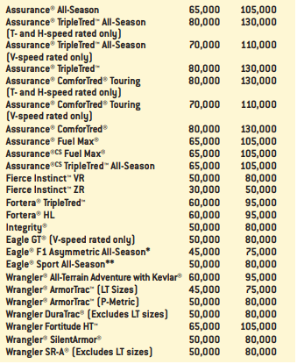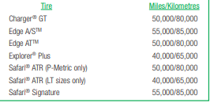

- Manufacturer Defect
  - Conditions such as Ply gap, wild wires, molding defect, sidewall bulge, tread separation, etc.
  - If tires are within first year and first 2/32s, tires will be covered at 100% credit.
  - If DOT is within a year , no invoices are needed.
  - After the first year, or first 2/32s of treadware, tires will be pro-rated based off of remaining tread depth.

Immediate Rejections
- Goodyear and Kelly do not have a Road Hazard warranty, check to see if the customer is under K&M’s Road Hazard program and process the tires through those guidelines.
- If the wrong dollar amount is put into the Replacement Price box on the Goodyear website, the tires will be instantly rejected. It is VERY important to put the amount the customer had to pay to get the replacement tire. DO NOT put the amount of the tire, or the amount that was credited to the customer.
- Adjustment Tire Labels must be on EVERY tire that is sent in and filled out correctly. If the labels are not filled out or are filled out wrong the tires will be rejected.
- Every authorization number must be called in if anything such as the tread is off by 1/32s or if there is mechanical wear this voids the authorization, and the tires must be sent back to the dealer.

Contacts for Goodyear/Kelly:
Frank Sullivan
Sullivan@goodyear.com
Goodyear warranty call center: 800-321-2136

Bridgestone/Firestone PLT Procedures
- Make sure that the tire falls under the guidelines to view these click on the link below: https://weblink2.kmtire.com/images/tireimages/Warranty/PassLT/bsfs%20brands.pdf
- Make sure all necessary documentation is acquired.
- Clear the estimate out of the system.
- Begin the claim in the intranet portal follow the steps from the intranet section.
- Open link below to access the Treadnet and this is where you will process the claim: https://b2b.bridgestoneamericas.com/b2bstorefront/b2b/en/USD/login
  - This will be the home page, click on warranty claims.

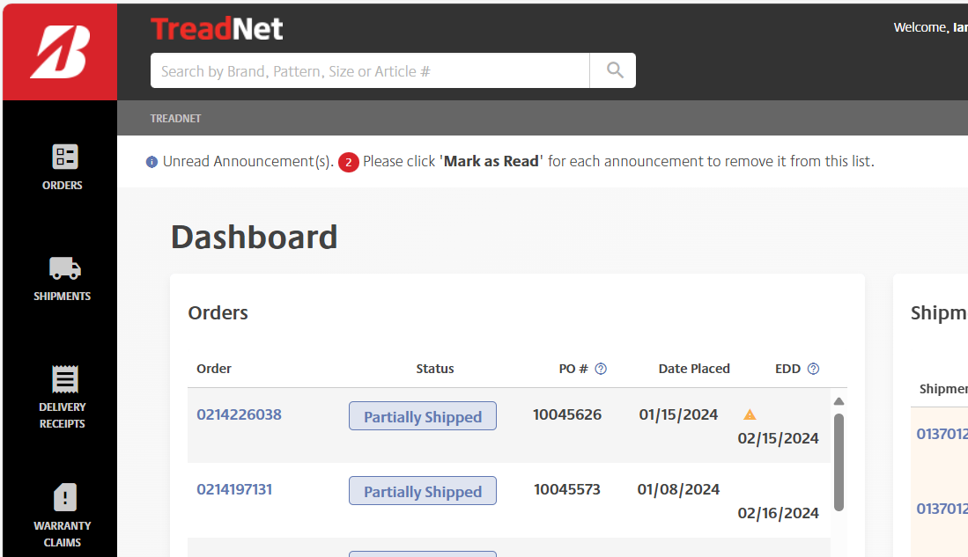

  - Click warranty claims and choose standard warranty adjustments.
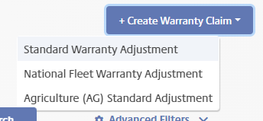

  - Company information will already be filled in automatically.
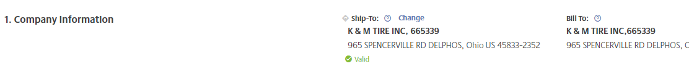
  - Warranty claim adjustments information will ask for a dealer reference number and store invoice # will just be the K&M claim number.

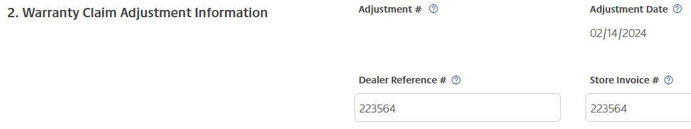

  - Customer information is the party receiving the credit.

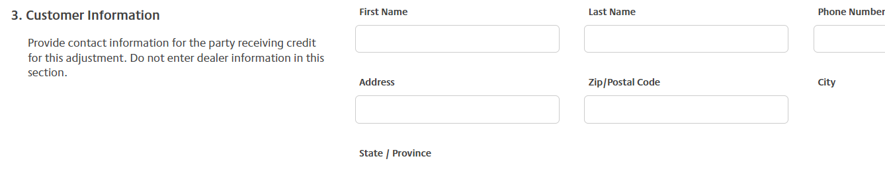
  - Vehicle information, if VIN is provided use, it and not check NO and move onto next section.
  - Tire information, fill out information that is provided the more the better.

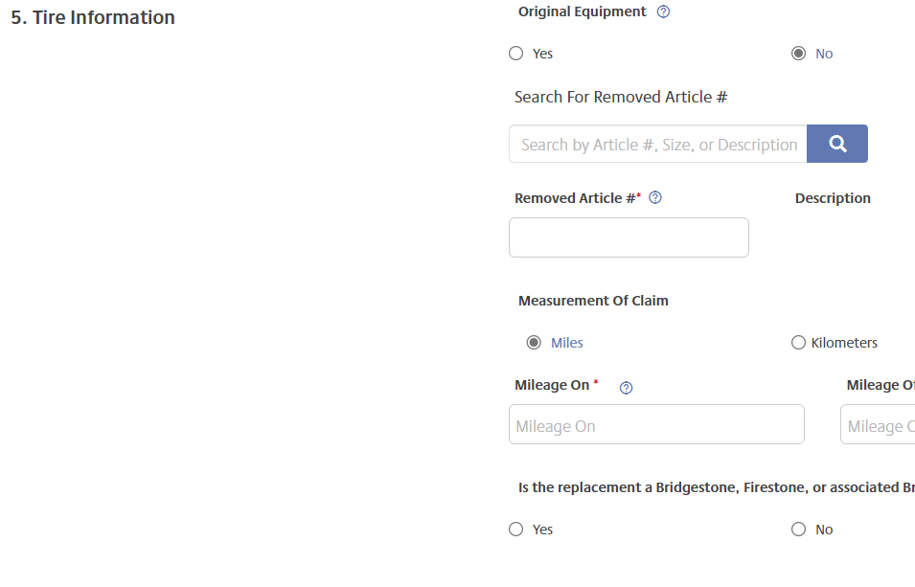

  - The tire line item is going to ask for DOT, RTD will the tread depth, current sales price is the current price the tire is being sold at, amount collected is the cost the customer is responsible for (EX. If it was 100% credit, the amount collected is $0), collected % will automatically fill in, wheel position can be other, RFID and serial # can be left blank, purchase date is date the tires where purchased, call log reference is K&M claim #, and reason for removal is why tires are being adjusted.

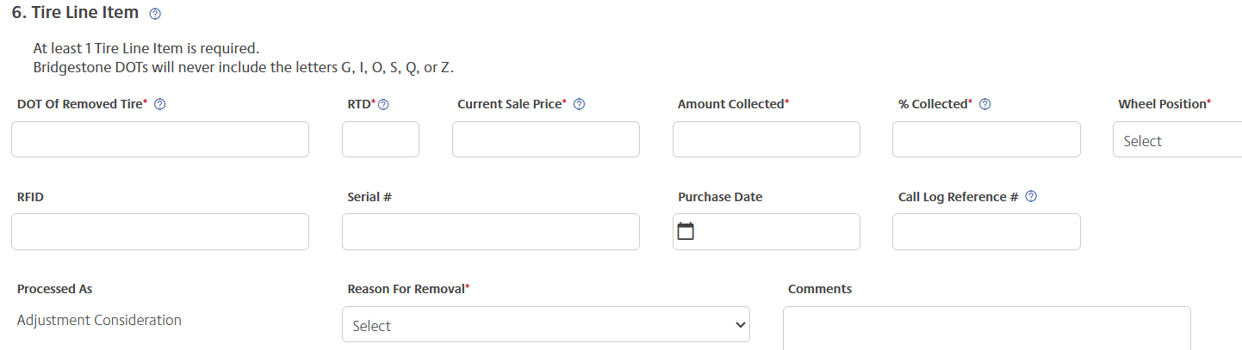

  - Attachments are any documents that the adjuster wants to upload. Once the information is completed click next and hit submit claim. You will be directed back to the main screen with all the claims.
  - You will need to click “E” ticket # that was generated. This will also be the manufacturer claim #.

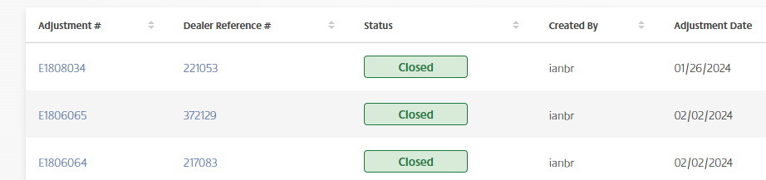

  - Once you click the “E” number you will be redirected to a new screen. Click on print options and print off both forms. L)
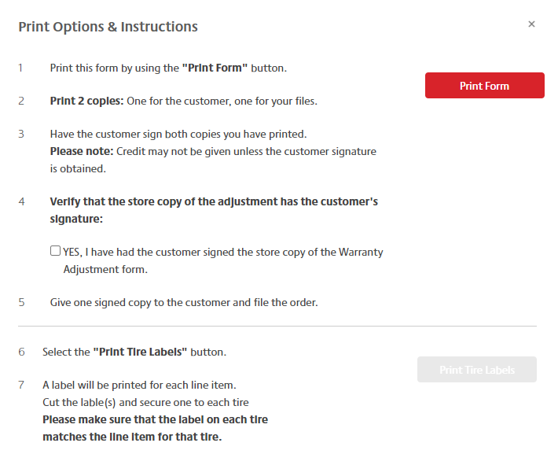

  - This print form is the claim form that will be stapled together with any documentations provided by the customer. Print tire labels that will need to be tapped to the tire. Once this is all completed the tire can be placed in the shipping area waiting to be shipped back to manufacture for further inspection.

The warranty Guidelines
Bridgestone and Firestone have the same general guidelines when it comes to giving 100% credit for a tire or pro-rata the tire based on the tread depth remaining on the tire. If the tire is new within the first 2/32s and first year ANY manufacture defect it’s covered at 100% credit. If the tire is not within the first year it may be pro-rata up to 6 years after the sixth year the warranty is voided.

Out of around- If the tire is within the first 2/32s and first year the tire can be covered at 100% credit up to 2 tires can be sent in per claim. The tires cannot have any punctures, mounting damage, or be worn more than 2/32s.If the DOT date is not within the year then purchase and replacement history is required. Please note that only one tire can be sent in for pulling on the Bfentirenet portal.
Road Hazard- There is NO road hazard for either Bridgestone tires.
90 day buy and try- Must be within the first 2/32s must have both purchase and replacement invoices within the 90 day limit. Tires must not have punctures or severe damage to tires. Only four tires can be submitted at a time no more and no less.
Weather Cracking- is 4 years from the manufacturer date not covered under the premium warranty.

Mileage Chart for Bridgestone
Listed here is the mileage for all the Bridgestone/Firestone tires. If the mileage is more than the limit this will void the warranty. Each claim will need purchase and replacement invoices along with the rotation records. The rotation must be in either be before every 7,000-8,000 miles or in between this if the rotations don’t meet these requirements this will void the mileage warranty.

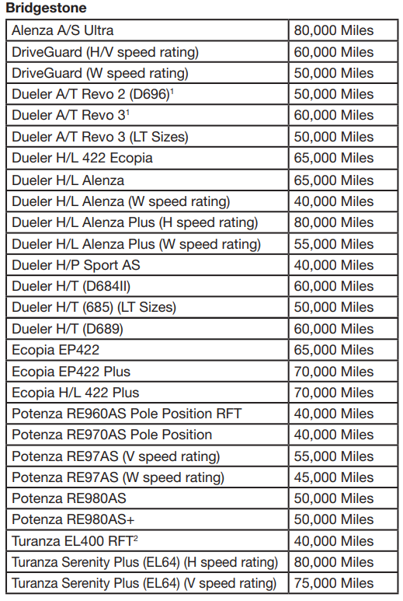
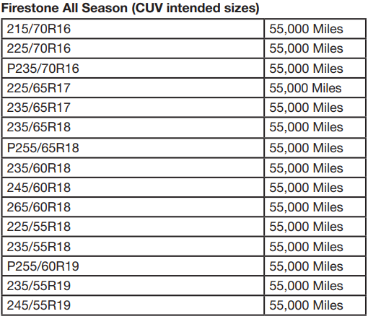
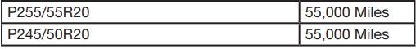
For mileage the remaining tread must be consistently between 0-4/32s anything that is more or less voids the warranty. For example, a tire pulls 5/32s this wouldn’t be covered if the tire is pulling a 3/32s this would be covered. If the tire has any road hazards this will make void the warranty. If the remaining tread has a difference of more than 1/32s then this would void the warranty. Example if a tire pulls a 4/32s on one side and a 2/32s this would not be covered but if the tire pulled at 4/32s and 3/32s this would.

Contacts for Bridgestone/Firestone:
Theresa Haney
HaneyTheresa@bfusa.com
Bridgestone/Firestone warranty call center: 800-847-3272

Carlisle/Carlstar AG Adjustment Procedures

- Make sure that the tire falls under the guidelines. To view these, click this link
- https://weblink2.kmtire.com/images/tireimages/Warranty/ag-industrial/Carlisle.pdf
- Make sure all necessary documentation is acquired.
- Clear the estimate out of the system.
- Begin the claim in the intranet portal and follow the steps from the intranet section.
- Fill out the Carlisle claim form. This can be found by going to the: F-Drive/Adjustments/Public/Adjustments Vendor Procedures/Carlisle Adj Procedures/Carlisle AG-OTR Claim Form

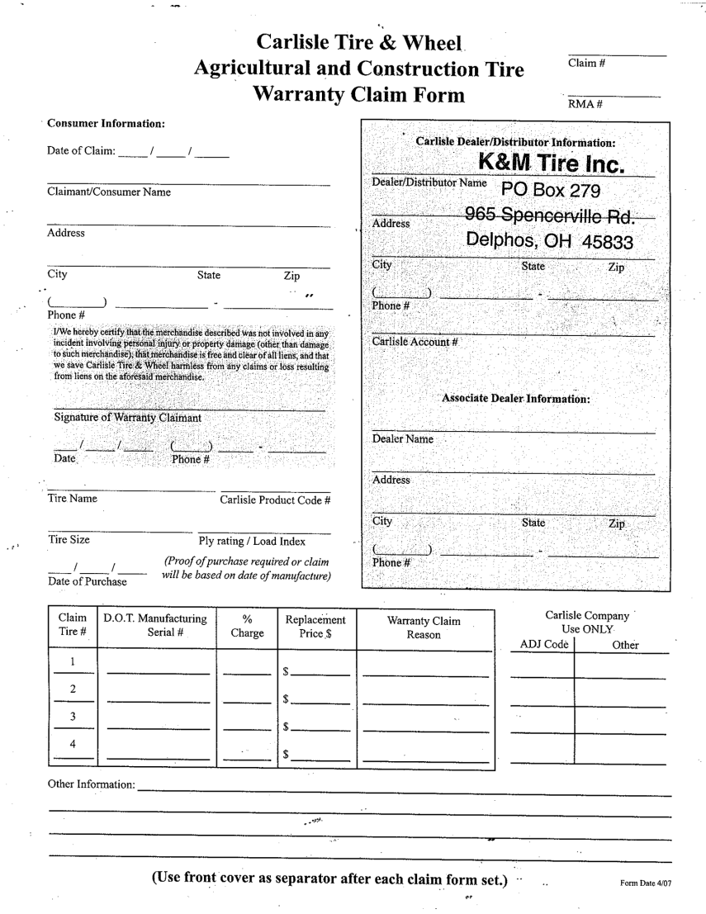

- Claim # will be the K&M claim # that the customer provided, in front of the number insert the abbreviation “CA”.
- Consumer information is going to be the customer information submitting the claim.
- Add the tire information (tire name, product #, tire size, and ply rating) and the associate dealer information will always be K&M Location.
- D.O.T. #, % charge, replacement price (put total $ amount the tire is being credited for, including anything pro-rate to simplify instead of using percent charge), and warranty claim reason.
- Once the claim form is completed, the claim form, any documents that were provided, and the pictures of the tire need to be sent in an email to the following people. customer.care@carlstargroup.com
- Once the email has been sent, the tire can be scrapped.

The warranty Guidelines
Carlisle has the same general guidelines when it comes to give 100% credit for a tire or pro-rata the tire based on the tread depth. If the tire is new within the 1st 2/32s and 1st year, ANY manufacture defect is covered at 100% credit. If the tire is not within the 1st year, it may be pro-rata. Anything manufactured before January 1, 2010, will void the warranty.
Out of round- if the tire is within the 1st 2/32s and 1st year, the tire can be covered at 100% credit. The tires cannot have any punctures, mounting damage, or be worn more than 2/32s.
There is NO road hazard for any Carlisle tires.
Pinhole- If the tire is within the first 2/32s and 1st year, then it is covered at 100% credit. Anything after the 1st 2/32s of tread will NOT be covered.
Bead failure- If the tire is within the first 2/32s and 1st year, then it is covered at 100% credit. Anything after the 1st 2/32s or first year, then a pro-rata must be given. Bead failures must not have any damage to the bead area away from the bead damage site. Bead must have wire ripped through.
Tread/belt separation- If the tire is within the first 2/32s and 1st year, then it is covered at 100% credit. Anything after the 1st 2/32s or first year, then a pro-rata must be given.
Workmanship Warranty – any defect in the tire caused by the manufacturing process.
Below is the chart on how to determine the credit for workmanship warranty.
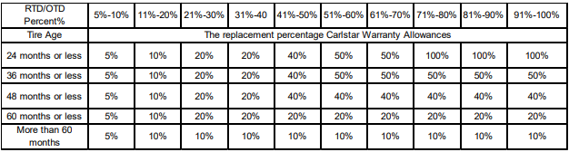
- To determine the credit, take the Remaining tread depth of the tire divided by the original tread depth. This will give the percentage worn.
- Next, find the time in service. If documentation is not provided, the DOT can be used.
- Once the Percent worn and the Time in service is determined use the chart to determine credit percentage. * Always default to the lowest credit. Ex.) If the tread is worn 50%, but was only in service for less than a year, use the worn % to determine credit.
- The chart shows the collection percentage. So, use the difference for the credit. Ex.) 5% collection is a 95% credit.

Field Hazard/Stubble Damage – the tire becomes unserviceable due to stubble damage or a puncture in the tread from a foreign object.
Below is the breakdown on how to determine the credit.
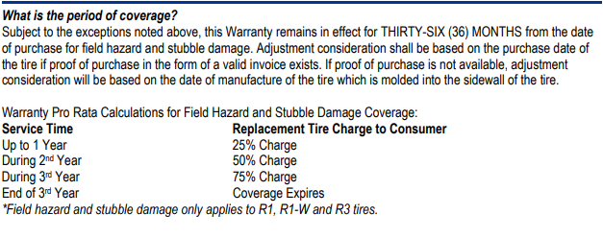

BKT AG Tires

BKT AG Warranty
- Make sure that the tire falls under the guidelines to view these click this link https://www.tireimages.com/Warranty/ag-industrial/bkt-radial.pdf or https://www.tireimages.com/Warranty/ag-industrial/bkt-bias.pdf
- Make sure all necessary documentation is acquired.
- Clear the estimate out of the system.
- Begin the claim in the intranet adjustment portal follow the steps from the intranet section.
- Fill out the BKT claim form. This can be found by going to the F-Drive/Adjustments/Public/Adjustment Vendor Procedures/BKT Adj Procedures/Blank Adjustment Form (word document)
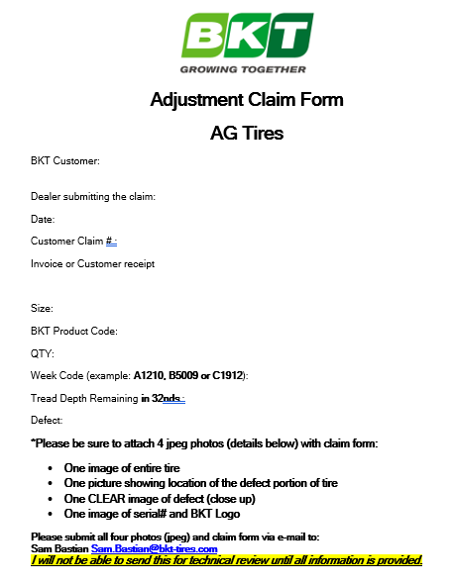
- BKT customer this will be the customers information.
- The date is when the claim is being submitted.
- The customer claim number will be the K&M claim number.
- Invoice or customer receipt can be left blank.
- Size is the size of the tire(s) that are being processed.
- BKT product code will be BKT part number.
- Week code is the DOT of the tire(s).
- The tread depth remaining in 32nds is the tread depth reading that was taken.
- Defect this is the reason the tire is being submitted for warranty.
- Once the claim form is completed, the claim form, any documents that were provided, and the pictures of the tire need to be sent in an email to the following people.
  - Sam Bastian - Sam.Bastian@bkt-tires.com
  - Jeff Smiley - Jeff.Smiley@bkt-tires.com
  - Dave Paulk - Dave.Paulk@bkt-tires.com

What is warrantable BKT Radial
Below are the charts on how to determine credit percent.
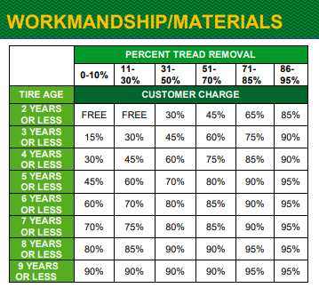
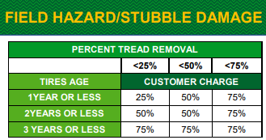
- Workmanship- This is anything that causes the tire to fail due to a manufacturer issue.
Ex.) Sidewall bulge, Sidewall Bubble, Pinhole leak, Molding issue etc.

- Field Hazard/Stubble Damage- This is a puncture in the tire caused by a foreign object causing the tire to fail. Stubble damage is caused by corn stubble tearing apart the lugs of the tire.
- Customer Charge is the amount the end user is responsible for paying. The credit would be the difference to make the end user whole. Ex.) 30% customer charge would result in a 70% credit from K&M.

What is warrantable BKT Bias
Below are the charts on how to determine credit percent.
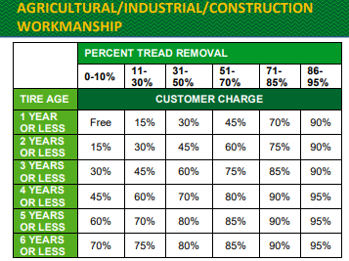
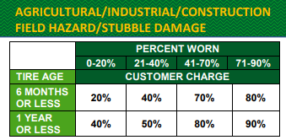
- Workmanship is anything that causes the tire to fail due to a manufacturer issue. Ex.) Sidewall bulge, Sidewall Bubble, Pinhole leak, Molding issue etc.
- Field Hazard/Stubble Damage this is a puncture in the tire caused by a foreign object causing the tire to fail. Stubble damage is caused by corn stubble tearing apart the lugs of the tire.
  - Documentation is not required but is preferred to help the customer get as much credit as possible. DOT can be used if no documentation is provided.
  - Any tire that’s DOT is before July 1st, 2016, does not carry a warranty (No exceptions).
Once the claim form is completed, any documents that were provided, and the pictures of the tire are sent in and emailed, the tire can be scrapped into the tire.
Contact for BKT AG
Sam Bastian - Sam.Bastian@bkt-tires.com
Jeff Smiley - Jeff.Smiley@bkt-tires.com
Dave Paulk - Dave.Paulk@bkt-tires.com
BKT Call Center - 1-888-660-0662

SOP# 2
- Step 1
- Step 2
- Step 3

SOP #3
- Step 1
- Step 2
- Step 3

Firestone AG Procedures

- Make sure that the tire falls under the guidelines to view these clicks link https://www.tireimages.com/Warranty/ag-industrial/firestone-farm-forestry-warranty.pdf?bcs-agent-scanner=d3b2189e-e70f-4e42-aefe-5e9518772145

- Make sure all necessary documentation is acquired.

- Clear the estimate out of the system.

- All Firestone Ag claims must provide purchase and replacement invoices and if they aren’t replaced with another firestone, it is a RAR.

- Begin the claim in the intranet portal follow the steps from the intranet section.

- Open the Treadnet to submit a warranty claim: https://b2b.bridgestoneamericas.com/b2bstorefront/b2b/en/USD/warranty/warranty-details/01231062

- This will be the homepage, click on Warranties.
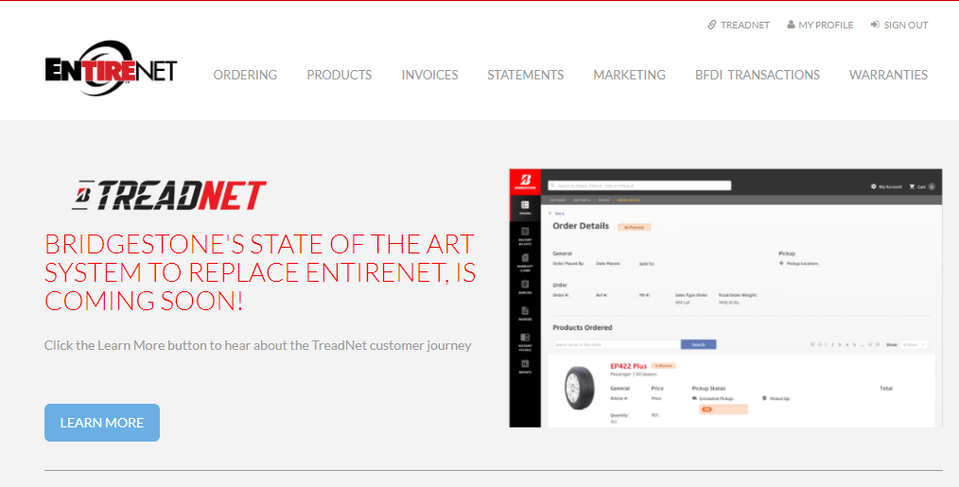

- From here click on Warranty claim tab.
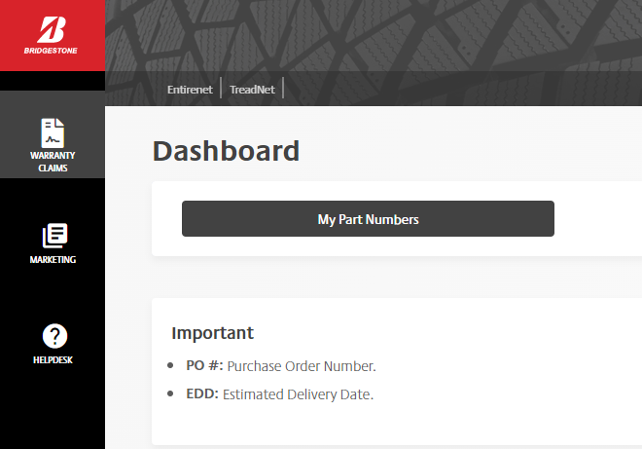
- Click on create warranty claim. Be sure to choose the correct warranty type, in this case it would be agriculture standard adjustment.



New Warranty Claim sections:
- Company information will already be filled in.

- Warranty claim adjustment information will ask for a dealer reference number.
- This will just be the K&M claim number, the store invoice can be left blank.
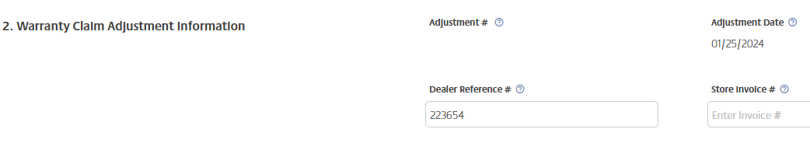
- Customer information is the party receiving the credit.

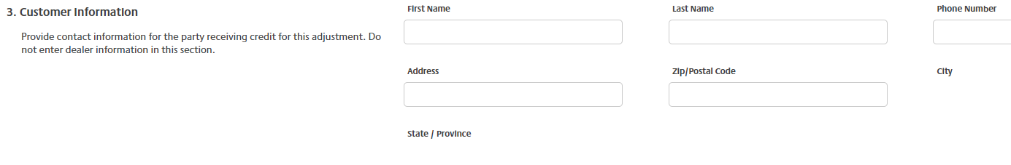

- Vehicle information, typically this information is never provided. If available enter the equipment the tire was on, if none leave this section blank.
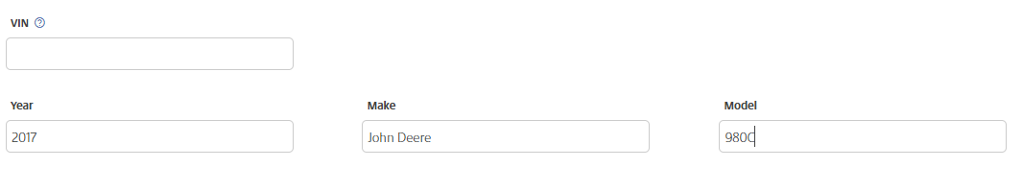

- Tire information check off if the tire is original equipment or not. Then enter the product code and search for the tire. Once entered it will pull up all the information related to the part number. Do the same for the replacement part number. This section will ask how many miles it was run for. Since AG equipment doesn’t go off miles, only hours of use, put 0 in both sections.
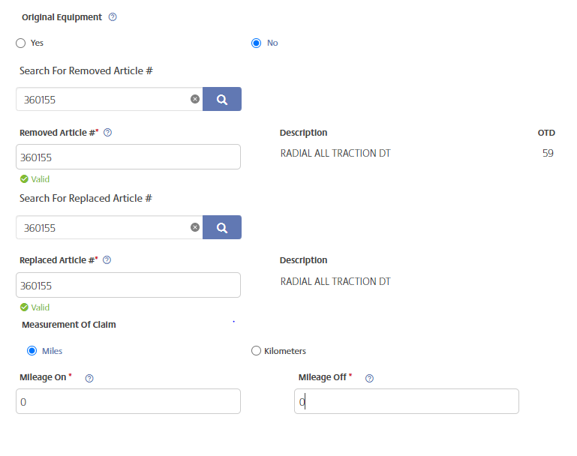

- The tire line item is going to ask for the DOT, remaining tread depth along with the current sale price, then the dollar amount collected, and the wheel position. If there is more than one tire, click the add line button and enter the required information.

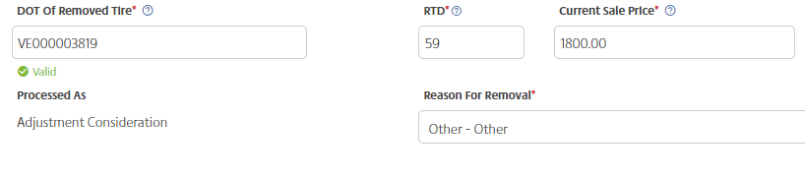
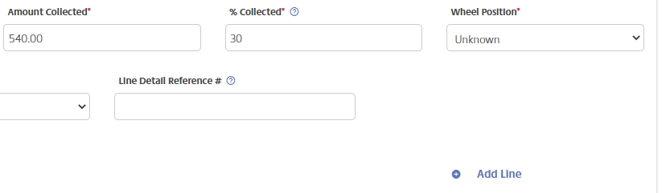
- This is going to be the most important part of creating the claim when it comes to K&M receiving credit back. For the current sale price this MUST be the price of the purchase invoice from the dealer to the end user. It can NOT be the price K&M sold the tires at. PLEASE NOTE: IN THE INTRANET PORTAL, THE PRICE THE DEALER BOUGHT IT AT WILL STILL BE USED. THE DEALER SOLD PRICE IS ONLY FOR TREADNET. Refer to the Firestone AG formula below.
- Firestone AG formula example: This is the Firestone AG formula. This needs to be used with EVERY Firestone AG claim. The four key parts that are needed are K&Ms current cost of the tire, what the dealer bought the replacement tire from K&M at, the collection rate percentage, and what the dealer sold the tire to the end user TODAY.

To find K&Ms current costs of a tire go to the madden-co section.
- In this example K&Ms current cost is $999.12. The dealer bought the replacement tire for $1089.00.
- $1089-$999.12= a $89.88 mark up
- The collection rate is 50%. This needs to be taken away from what the dealer sold the replacement tire to the end user. In this example they sold it at $1250
- $1250 X .50 = $625 PLEASE NOTE THE $1250 IS WHAT GOES INTO TREADNET FOR REPLACMENT PRICE
- This number ($625) is what the dealer needs to be whole. This is the credit they are looking for.
- K&M will subtract the $625 from our cost.
- $999.12-$625=$374.12
- This number ($374.12) is what K&M will get back from firestone AG, not what will be credited back to the dealer.
- The dealer needs the credit K&M would receive along with the mark up price.
- $374.12+89.88=$464.00
- The $464.00 IS WHAT K&M WILL CREDIT TO THE CUSTOMER. Now the dealer needs $625 to be whole, so the extra money they would be looking for would come from their profit on that replacement tire.
- What they sold it minus what they bought the replacement tire from K&M at $1250.00-$1089.00=$161
- Take $464+$161= $625 now the dealer is whole. It is very important to understand the dealer has to take into account their profit from the replacement.

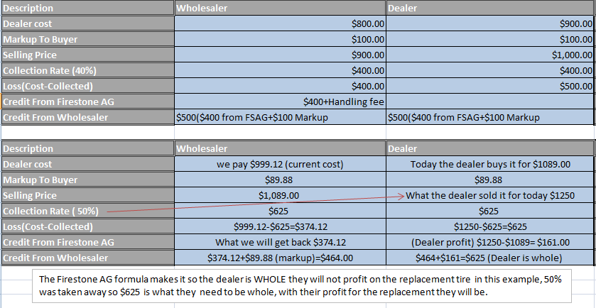
Firestone AG auto fill example: There is also an auto fill example with the four key numbers highlighted in green. When those numbers are plugged in this will auto calculate what the dealer will be credited. The number is highlighted in yellow.
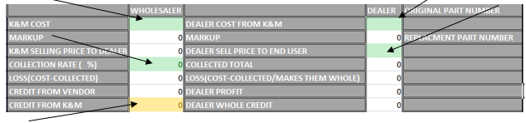

- A copy of the spreadsheet needs to be printed off with every claim and scanned into the intranet portal. This allows others to see the work that was done to determine the credit.
- This can be found by going to the F-drive/Adjustments/Public/Adjustment Vendor Procedure/Bridgestone-Firestone ADJ Procedures/AG Adjustment Formula guide.

- This E-ticket number will be the manufacture claim number used in the intranet portal. After all the information is entered the claim can be submitted and an E-ticket will generate just like a PLT tire. This will need printed out and taped to the corresponding tire. From there the paperwork for the tire needs saved and added to the shipping spreadsheet.
- This E-ticket number will be the manufacture claim number used in the intranet portal. After all the information is entered the claim can be submitted and an E-ticket will generate just like a PLT tire. This will need printed out and taped to the corresponding tire. From there the paperwork for the tire needs saved and added to the shipping spreadsheet.

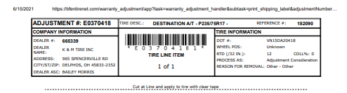

The warranty guidelines:
When it comes to Firestone AG there is a multiple charts and guidelines to follow all depending on the class of tire. Radial tires, performer evos radial, bias, forestry tires, and then certain tires can get stubble damage/ field hazard coverages. All have different pro-rata percentages and collection rates.

Radial Tires:
- Firestone radial tires will have the longest warranty period, going up to 9 years. If the tire is going to receive 100% credit the dealer can claim labor and service fees up to $300.00 per claim
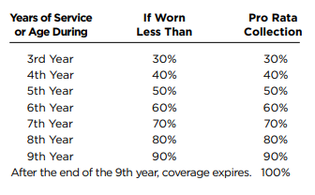
- This is the radial pro-rata chart when determining how much credit a dealer should get back. Always refer to this for AG. Firestone doesn’t credit down to the exact amount worn off the tire they will round up or down. To determine the credit amount, purchase and replacement invoices must be provided to see the service life of the tire.

Formula for exact percentages worn:
- What the tire comes new with/100----59/100=.59
- Remaining tread depth/new tread divided by 100----32/.59=54%
- 100% tread life-remaining percentage----100%-54%=46% worn
- So, if the tire is 46% worn it is higher than 40% this means that the tire must be bumped up to the 5th year 50% collected even if it is only 3 years old. The tire MUST be worn exactly or less to receive a higher credit amount if not it automatically goes up to the next on the chart.

Performer Evo Radials
Firestone performer evo radial tires have a warranty period of 6 years. If the tire is going to receive 100% credit the dealer can claim labor and service fees up to $300.00 per claim. The warranty for these tires is shorter due to them being a premium tire.
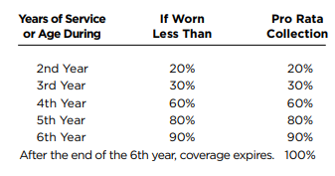
The same worn percentage formula can be applied here.

Bias Tires
Firestone bias tires have a 6-year warranty period. The difference between bias and radial is the construction of the tire. The easiest way to tell the difference is the size of the tire so it is a 380/50R42. It is a radial generally if it doesn’t have the R in the size it is a bias. Bias tires Due to their multiple layers, bias ply tires generally have the advantage when it comes to load-carrying capacity. Because there are a uniform number of plies to support the weight of a vehicle in both the tread face and the sidewall, bias ply tires are generally better when hauling heavy loads. This is why trailer tires, tractor tires, and heavy equipment tires are often bias ply; they can better support heavy loads. Radials are available with high load ratings, but the weight-carrying capacity requires adding many more plies to a radial tire, making them very stiff. Radial tires in performance applications, tires see significant side loads as a vehicle moves through corners. The attributes that give radial good overall pavement manners are the same ones that make them superior when it comes to handling abrupt corners, sweeping turns, and other performance maneuvers. A bias ply tire doesn’t respond as well to cornering forces, especially as the width of the sidewall increases. In straight-line handling there is little difference between a radial and a bias ply, but cornering performance varies significantly.
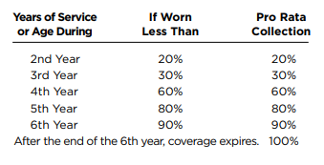
This is the worn percentage chart for Bias ply tires. The same worn percentage formula can be applied here.

Forestry Tires
Firestone Forestry tires do not have a chart to go off. They have a warranty period of 5 years from service invoices or DOT, but these are all pro-rata based on the tread amount used compared to what is left. So, this would be the same as any other adjustment warranty. This is the only firestone AG tire in which the collection rate percentage won’t necessarily be a whole number as the other charts have.

Stubble Damage
  - Firestone AG has a policy for stubble damaged tires up to three years. Listed below are all tires that can qualify for this limited warranty.
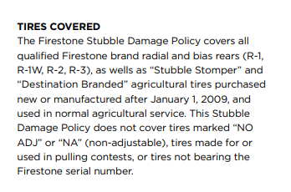
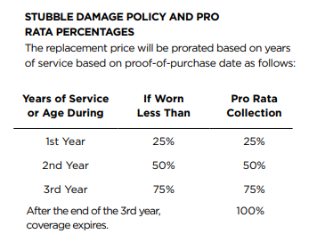

  - What is stubble damage?
  - Stubble comes from the fields when farming. A crop like corn has a stalk. This allows the plant to stay up against weather conditions and once the farmer takes the crops off what is left is the hardest piece of the stalk. Based on the MOHS hardness test the stalk is generally going to be harder than the rubber of the tire, so if the tire is constantly going over the stubble eventually it will pick away from the rubber causing the tire to show cord/belts that can lead to failure.

Field Hazard
Firestone AG has a policy for field hazard damaged tires for up to two years. Listed below are all the tires that can qualify for this limited warranty.
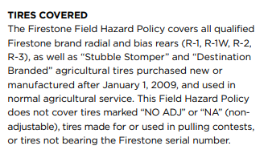
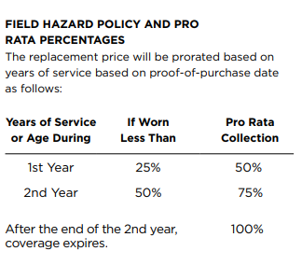

Field hazard is the term used for when the inner liner is punctured due to something out in the field; this is the road hazard of AG tires.

Contacts for Firestone AG:
Joe Woodward
WoodwardJoseph@BFUSA.com
Joe’s cell phone number: 330-715-8365
Appendix A: Supportive Documents
How we can help at the field level?
Inventory Specialist:
Sales Department:
Purchasing Department:
Credit Department:

Instructions: Provide a list of acronyms and associated literal translations used within the document. List the acronyms in alphabetical order using a tabular format as depicted below.

Table 2 - Acronyms
Acronym | Literal Translation
<Acronym> | <Literal Translation>
Kayla Perrine | Firestone AG Procedures
Kayla Perrine | Added Firestone & Bridgestone PLT Procedure
Kayla Perrine | Updated 6.1 and Added 6.4
Kayla Perrine | Added 6.5

Appendix H: Revision History Tracking
The following table records information regarding changes made to the Operations Binder.

Table 6 - Revision History Tracking
Version Number | Date | Author/Owner | Description of Change

